

*Organisation: Solar Boat Sealander*

*Client: Mr. R. Eijlers*

*Tutor: Mr. W. Haak*

*Date: 28-01-2021*

Research Report

Propulsion system simulation

Fangzhou chen Jiacong li Marco Hoogesteger Martijn Crombeen

2020

# Information

This project is being executed by students of the mechatronics course at the HZ University of Applied Sciences, in cooperation with exchange students from the SMU in China. The following sections will state general information about the client and project members.

**Client information**

Organisation: Solar boat Sealander

Address: Edisonweg 4

Location: Vlissingen

Postal code: 4382 NW

Name client: Ronald Eijlers

E-mail: [ronald.eijlers@hz.nl](mailto:ronald.eijlers@hz.nl)

**Academy details**

Company: HZ University of applied sciences

Address: Edisonweg 4

Location: Vlissingen

Postal code: 4382 NW

Phone: +31(0)118 489 000

Name tutor: Willem Haak

Phone: +31(0) 6 48197930

E-mail: [w.haak@hz.nl](mailto:w.haak@hz.nl)

**Student Information**

Name: Martijn Crombeen

Student#: 73398

Phone: +31(0) 6 37120741

E-mail: [crom0004@hz.nl](mailto:crom0004@hz.nl)

Background: Mechatronics

Project Role: Project leader / contact person

Name: Marco Hoogesteger

Student#: 76556

Phone: +31(0)6 28726699

E-mail: [hoog0097@hz.nl](mailto:hoog0097@hz.nl)

Background: Mechatronics

Project Role: Project member

Name: Jiacong Li

Student#: 82749

Phone: +31(0) 6 45637440

E-mail: [li0042@hz.nl](mailto:li0042@hz.nl)

Background: Electrical Engineering

Project Role: Project member

Name: Fangzhou Chen

Student#: 82753

Phone: +31(0) 6 83159840

E-mail: [chen0061@hz.nl](mailto:chen0061@hz.nl)

Background: Mechatronics

Project Role: Project member

**Hierarchy**

# Abstract

Solar powered travel is something that has been booming for the last few years. It can clearly be seen that current developments such as global warming has a very negative impact on the environment. Many recent studies and projects have been finding and experimenting with different environmentally friendly solutions to combat this rising trend. One of these solutions is the use of solar energy. The HZ also contributes to this research with their solar boat. This boat is being developed by a team of students from different areas and is used to compete in yearly solar boat races. There, the teams have to face off against other students with different boats.

# Foreword

Before you lie the research report of the “Propulsion System Simulation of the Solar Boat”. This is the documentation of the research and design of the simulation, verified by empirical data from the MARIN. This report has been written to give the client and the tutor an overview of the project and proving the team’s skill. The complete system design can be found in the appendix, in the chapter “V-model”.

First and foremost, the project team would like to thank the client, Mr. Eijlers, for the opportunity to execute this project and learning lots of information about simulating and the boats’ propulsion system. The nautical background of the client also helped the project team because lots of information could be gathered straight from the client.

Secondly, we would like to thank Mr. Haak for the relevant feedback and support throughout the whole project, which assured the final result was according to the expectations of both the client and assessors from the HZ University of Applied Sciences.

Jiacong Li  
Fangzhou Chen  
Marco Hoogesteger  
Martijn Crombeen

Vlissingen, January 28th 2021

# Abbreviations

Since this is a project performed by an international project team, it is written in English. The client is Dutch, so for the abbreviations, also the Dutch description is given.

|  |  |  |
| --- | --- | --- |
| Abbreviation | English description | Dutch description |
| MARIN | Maritime Research Institute Netherlands | Maritiem Onderzoeksinstituut Nederland |
| MAROF | Maritime Officer | Maritiem Officier |
| HZ | University Zeeland | Hogeschool Zeeland |
| UAS | University of Applied Sciences | Universiteit van toegepaste wetenschappen |

Table of content

Information 2

Abstract 4

Foreword 5

Abbreviations 6

List of Figures 9

1. Introduction 13

1.1. Background 13

1.2. Problem statement 13

1.3. Goals and objectives 15

1.4. Requirements 16

2. Theoretical framework 17

2.1. Operational characteristics of propulsion components 17

2.2. Input power 17

2.3. Factors affecting the propulsion system 17

2.4. Power loss in the gearbox 18

2.5. Simulate the resistance caused by wind 25

2.6. Simulation of the resistance caused by waves 26

2.7. Simulation of the resistance caused by ocean current 27

2.8. Define the output power of a ship's propulsion system 27

2.9. Motor characteristic curve 28

2.10. Propeller characteristic curve 30

3. Method 34

3.1. Overview 34

3.2. Reasons of choice 34

3.3. Usage of method 35

4. Results 36

5. Discussion 40

5.1. Discrete discussion of results 40

5.2. Conclusion 40

5.3. Recommendation 40

6. Bibliography 42

7. Appendices 44

7.1 V-model design phase (demo) 44

7.2 V-model design phase (system) 46

7.3 V-model design phase (subsystem) 51

7.4 V-model design phase (component) 60

7.5 V-model integration phase (component) 94

7.6 V-model integration phase (subsystem) 104

7.7 V-model integration phase (system) 108

# List of Figures and tables

Figure 1 Calculation chain 15

Figure 2 Power distribution 17

Figure 3 Composing of the power loss 18

Figure 4 Power loss with different immersion depth 19

Figure 5 Power loss with different kinematic viscosity 20

Figure 6 Gear type 22

Figure 7 No load loss of bearing 23

Figure 8 Load-dependent loss of bearing 23

Figure 9 Waterinfo map by Rijkswaterstaat 26

Figure 10 Wave height aug.-sep. in Honte nearby Sloehaven 26

Figure 11 Overview of the water and currents of earth 27

Figure 12 Motor drawing 28

Figure 13 Motor n/P/T-I curve on 48V 29

Figure 14 Motor T-n curve on different voltage 29

Figure 15 T-N curve of the motor connected to the propellor 30

Figure 16 Propeller characteristic curve 30

Figure 17 V-model structure 34

Figure 18 Propulsion simulation system flowchart 36

Figure 19 User-interface in simulation 37

Figure 20 Motor used in the solarboat 37

Figure 21 Gearing used in the solarboat 38

Figure 22 Propeller used in the solarboat 38

Figure 23 Final results validation 39

Figure 24 Flowchart system 46

Figure 25 Flowchart user-interface 51

Figure 26 Flowchart calculations 56

Figure 27 Flowchart motor 60

Figure 28 Realistic calculation motor 63

Figure 29 Theoretical calculation motor 64

Figure 30 Flowchart gearing 66

Figure 31 Gear type 73

Figure 32 Data gearing 73

Figure 33 Flowchart bearing 74

Figure 34 Flowchart propellor 77

Figure 35 Flowchart input block 82

Figure 36 Formula input block 85

Figure 37 Flowchart output block 86

Figure 38 Formula 1 output block 88

Figure 39 Formula 2 output block 88

[Figure 40 Piechart output block] 88](#_Toc62742541)

Figure 41 Flowcharts prompts 90

Figure 42 Structure prompts 92

Figure 43 Code prompts 92

Figure 44 Successful simulation 93

Figure 45 Unsuccessful simulation 93

Figure 46 Buildup motor 94

Figure 47 Realistic result motor 94

Figure 48 Theoretical result motor 94

Figure 49 Buildup gearing 96

Figure 50 Realistic result gearing 97

Figure 51 Theoratical result gearing 97

Figure 52 Buildup bearing 98

Figure 53 Result bearing 98

Figure 54 Buildup propellor 99

Figure 55 Result propellor 100

Figure 56 Result warning numeric 101

Figure 57 Result warning non-numeric 101

Figure 58 Result input block 102

Figure 59 Result 2 input block 102

Figure 60 Result output block 103

Figure 61 Result 2 output block 103

Figure 62 Buildup user interface 104

Figure 63 Buildup properties 104

Figure 64 Buildup warnings and prompts 104

Figure 65 Results properties 105

Figure 66 Results numeric boat speed 105

Figure 67 Result non-numeric boat speed 105

Figure 68 Result properties non-numeric 106

Figure 69 Results properties 0 106

Figure 70 Result prompts 106

Figure 71 Result 2 prompts 106

Figure 72 Results sub system calculations 108

Figure 73 Buildup system 109

Figure 74 Results system test 110

Figure 75 Legend system test 110

Figure 76 System test successful simulation 111

Figure 77 System test unsuccessful simulation 111

Table 1 Properties of gearing 22

Table 2 Coefficient of friction with different bearings 24

Table 3 Average wind speeds in the Netherlands 25

Table 4 Motor parameters 28

Table 5 Deliverables list in different phases of V-model 35

Table 6 Constants demo test 44

Table 7 Inputs common situation 44

Table 8 Inputs unusual situation 44

Table 9 Outputs monitored 45

Table 10 Testing tools 45

Table 11 Unique identifiers system 46

Table 12 Table of limits system 46

Table 13 Table of properties system 48

Table 14 Constants system test 49

Table 15 Inputs system 49

Table 16 Outputs monitored 49

Table 17 Testing tools system 49

Table 18 Unique identifiers user-interface 51

Table 19 Table of limits user-interface 52

Table 20 Table of properties user-interface 53

Table 21 Constants user-interface 54

Table 22 Normal inputs user-interface 54

Table 23 Unusual input user-interface 54

Table 24 Outputs monitored user-interface 54

Table 25 Testing tools user-interface 54

Table 26 Expected results user-interface test 55

Table 27 Unique identifiers calculations 56

Table 28 Table of limits calculations 57

Table 29 Constants calculations 58

Table 30 Inputs calculations 58

Table 31 Outputs monitored calculations 58

Table 32 Testing tools calculations 58

Table 33 Expected results calculations (within margin) 59

Table 34 Unique ID motor 60

Table 35 Table of limits motor 60

Table 36 Variables motor 61

Table 37 General input motor 61

Table 38 Inputs for realistic calculation motor 61

Table 39 Inputs for theoretical calculation motor 61

Table 40 Outputs for realistic calculation motor 62

Table 41 Output from theoretical calculation motor 62

Table 42 Tools motor 62

Table 43 Unique ID gearing 66

Table 44 Table of limits gearing 66

Table 45 Variables gearing 67

Table 46 General input gearing 67

Table 47 Inputs for realistic calculation gearing 67

Table 48 Inputs for theoretical calculation gearing 67

Table 49 Outputs gearing 68

Table 50 Tools gearing 68

Table 51 Realistic calculation gearing 69

Table 52 Theoretical calculation gearing 70

Table 53 Unique ID bearing 74

Table 54 Table of limits bearing 74

Table 55 Friction coefficients bearing 74

Table 56 Variables bearing 75

Table 57 Inputs bearing 75

Table 58 Outputs bearing 75

Table 59 Tools bearing 75

Table 60 Unique ID propellor 77

Table 61 Table of limits propellor 77

Table 62 Variables propellor 78

Table 63 Inputs propellor 78

Table 64 Outputs propellor 78

Table 65 Tools propellor 79

Table 66 Unique ID input block 82

Table 67 Table of limits input block 83

Table 68 Variables input block 84

Table 69 Inputs input block 84

Table 70 Outputs input block 84

Table 71 Tools input block 84

Table 72 Unique ID output block 86

Table 73 Table of limits output block 86

Table 74 Variables output block 87

Table 75 Inputs output block 87

Table 76 Outputs output block 87

Table 77 Tools output block 87

Table 78 Unique ID prompts 90

Table 79 Table of limits prompts 90

Table 80 Variables prompts 91

Table 81 Inputs prompts 91

Table 82 Outputs prompts 91

Table 83 Tools prompts 91

Table 84 Conclusion test user interface 107

# Introduction

## Background

The Solar boat project has been running since 2008 and multiple changes have been made to the boat. In the current rendition of the boat, the hull and structure are made from fiberglass. Because this material is not eco-friendly, the next generation will be made from mostly biobased materials. Together with this change, the main contents of the boat will get an overhaul eventually. The main drivetrain components will be simulated by two groups of 4th year students.

## Problem statement

The current propulsion system on the solar boat can realize the function of propelling boat and controlling direction. But the narrow and long blades of the propeller cause high friction when the propeller is rotating and in contact with water. Because of the small contact area between the blades and water, the thrust output from propeller cannot be transformed fully into high propulsion speed of the boat. Another issue is that some components of the propulsion system are heavy, which increases the burden of the propulsion system and effects the energy conversion efficiency (rotational kinetic energy as input from motor and output as thrust from propeller).

Basing on the above problem analyzation, three main research direction can be followed:

* Change the size of the propeller to reduce energy consumption caused by friction.
* Change the shape of blades to produce high thrust and increase the propulsion speed.
* Check every component of propulsion system and reduce weights of propulsion system to improve energy conversation efficiency.

To find out what size and shape of the propellor, and what parameters of the drivetrain are optimal, it is needed to perform a simulation of the different components and calculate where the improvements must take place. By simulating the whole system with all its components, tests can be performed with different parameters for different components.

Therefore this project will focus on simulating the current propulsion system and validating it. This is a digital twin. Later different components can be inserted virtually to test its performance.

### Main question

What is the verified simulation to calculate the propulsion system of the Solar boat to improve its efficiency (to aid the choice of components)?

### Subtopic 1

What is the demo test plan?

### Subtopic 2

What is the system test plan?

### Subtopic 3

What is the subsystem test plan?

### Subtopic 4

What is the component test plan?

### Subtopic 5

What is the component test?

### Subtopic 6

What is the subsystem test?

### Subtopic 7

What is the system test?

### Subtopic 8

What is the customer acceptation?

## Goals and objectives

### Goal

The goal of this project is to satisfy the client, by developing simulations that will provide information and support not only for this particular project, but for every new version of the boat that will be built.

### Objectives

* A verified simulation built in Excel.
  + User-friendly interface.
  + Easy to learn.
* Calculation chain.

### Boundaries

In this project, simulations are built and validated focused on designing a new propulsion system. It is easy to go to deep in the project resulting in an inadequate final result. To prevent this, it is very important to set project boundaries. After discussion and consideration with the client and the group members, the project boundary has been set as followed.

Simulations regarding the motor, propeller, shaft, bearings and gearing will be made. With all these simulations, we can calculate the ideal torque and revolutions that the driveshaft has to receive from the motor. The Engineer that is going to design the whole new propulsion system and select components, can use this information to select the desired motor.

The following figure shows a simple block diagram displaying the project boundary.

Figure 1 Calculation chain

In the theoretical framework below, all kind of factors are displayed that could have some kind of influence on the performance of the propulsion system. A very difficult part of this are the variable properties of water. Ocean water can contain current, waves or different compositions, that all can lead to variable outcomes. For this project we stated that we don’t take the variables linked to water in account.

## Requirements

|  |  |
| --- | --- |
| Requirements List | |
| List of clients’ requirements | | **Demand** | **Wish** |
| 1. | The final deliverable work surprises the client. |  |  |
| 2. | The prototype is a calculation chain. |  |  |
| 3. | The client thinks the interface of the simulation is user-friendly. |  |  |
| 4. | Data is measured from the real setup for the verification of the calculation chain. |  |  |
| 5. | The propulsion system will be more efficient. |  |  |
| 6. | The errors between the results derived from the calculation chain and the results from the real Solarboat do not exceed 30%. |  |  |
| 7. | The calculation chain only focusses on the propulsion system so external resistances from water are not taken in to account. |  |  |
| 8. | All data are kept to two decimal places. |  |  |
| 9. | Provide some efficient component selection direction for those who design the boat’s propulsion system. |  |  |
| 10. | The correct formulas will be chosen to make the calculation chain. |  |  |
| 11. | The V-model is used as method. |  |  |
| 12. | The demo test plan is made. |  |  |
| 13. | The system test plan is made. |  |  |
| 14. | The subsystem test plan is made. |  |  |
| 15. | The component test plan is made. |  |  |
| 16. | The component test is made. |  |  |
| 17. | The subsystem test is made. |  |  |
| 18. | The system test is made. |  |  |
| 19. | The client is satisfied. |  |  |

# Theoretical framework

## Operational characteristics of propulsion components

This paper is aiming to reveal the details of energy conversion through of the solar boat’s propulsion system so that researchers can build a calculation chain to simulate and optimize the propulsion system with a higher efficiency. The solar boat’s propulsion system which consists of the electric motor (prime mover), the gearbox and shaft (transmission system) and the propeller (propulsor). Furthermore, the thrust delivered by the propeller has to overcome the ship’s resistance, which strongly depends upon the external forces that impose to the boat. So the wind and waves have been considered (Shi1 & Grimmelius, 2009).

## Input power

The energy of the propulsion system comes from the electric motor that is powered by the batteries, who in turn are powered by solar panels.

## Factors affecting the propulsion system

In the process of energy transmission, the output power of the motor cannot be completely converted into the output power of the propeller due to the influence of some factors. And due to the influence of other external factors, the propulsion power output by the propeller needs to overcome a series of resistances to result in the force that accelerates the solarboat.

The efficiency of the conversion of solar power to a moving solarboat could be divided into four parts; the hull efficiency, the propeller efficiency, the transmission efficiency and the engine efficiency. Since our boundary does not include the hull and motor, it was decided to use a fixed value to represent the hull resistance, which together with the output power from the motor is used as the input of the system (Shi1 & Grimmelius, 2009).

Motor

Input Power

Output Propulsion Force

Propulsion System

Internal Power Loss

External Power Loss

Figure 2 Power distribution

### Internal factors

Transmission efficiency and propeller efficiency are the main parts of the internal energy loss factors. The researchers figured out which components mainly caused the energy loss of these two parts. The main energy loss happened in the gearbox and propellers.

### External factors

The external energy loss mainly comes from wind and waves and the resistance of the hull. The researchers set the hull's own resistance to a fixed value. For the wind & waves in the ocean, the current intensity value is used, as they related to the Dutch sea area which is used in the simulation of the propulsion system of the solar ship.

## Power loss in the gearbox

The power loss in a gearbox is caused by gears, bearings, and seal and auxiliary losses (Klaus Michaelis, 2011). Gear and bearing losses can be separated into no-load losses, which occur even without power transmission. Except for the working conditions and the air gap in the gearbox, no-load losses are mainly caused due to lubricant viscosity and density, while the immersion depth of the components dipping into the lubricant also contribute to the no-load losses.

Load-losses depend on transmitted load, coefficient of friction and sliding velocity in the contact areas of the components. The power loss in gears is typically dominant in the nominal power transmission situation. For part load and high speed, high no-load losses dominate the total losses. For optimizing the whole operating range of a gearbox, it is needed to simulate the transmission flow using a calculation chain. In the following topics, the major factors that lead to gearbox power losses mainly consider the bearings & gears and shaft.

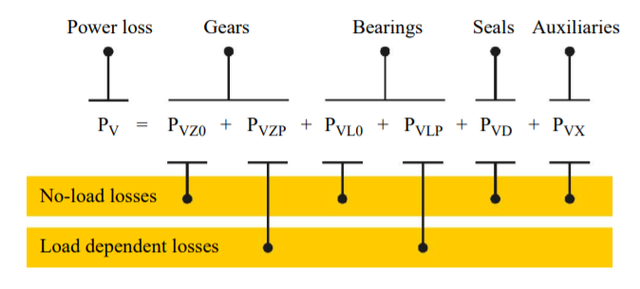

Figure 3 Composing of the power loss

### Power loss in the gears

#### No-load gear losses

The no-load gear losses ensue from immersion depth in sump lubricated gearboxes & lubricant viscosity in operating conditions. Since the operating conditions are uncontrollable, the immersion depth in lubricant and lubricant viscosity will be mainly concerned.

For immersion depth in a sump lubricated gearbox, the immersion depth of the gear will affect the meshing of the gear and cause the loss of energy. Therefore, at different immersion depths, the gear loss in this part is different (Lin Zou, 2018).

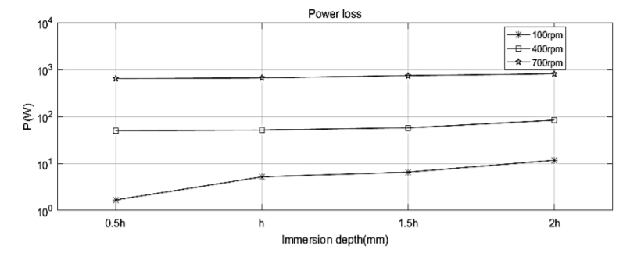

Figure 4 Power loss with different immersion depth

In **Fout! Verwijzingsbron niet gevonden.** it can be seen that high immersion depth may lead to higher energy loss, which is caused by lubricant resistance. But in order to prevent rust, reduce friction, heat dissipation and other disadvantages, we cannot blindly reduce the lubricant immersion depth. It is therefore crucial to find a suitable lubricant immersion depth range, which can achieve less energy loss and satisfy its function (Lauer, 2013).

The energy loss due to the lubricant mainly depends on the viscosity of the lubricant. High-viscosity lubricants will increase churning loss. The viscosity of the lubricant decreases with increasing temperature. When the load is immense, the lubricant with a high viscosity is suitable and when the speed is high, the lubricant with a low viscosity is suitable. Suitable lubricants are therefore needed for the solar boat (k.Michaelis&B.-R.Hohn).

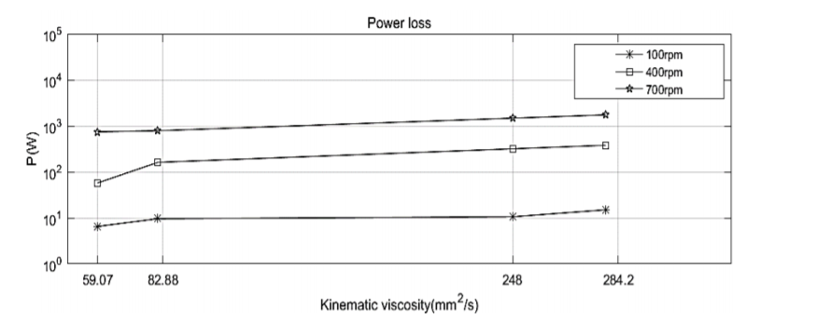

Figure 5 Power loss with different kinematic viscosity

From figure 7, it can be derived that the energy loss of high-speed gears is greater than that of low-speed gears.

#### Load dependent losses

The load gear losses $P_{vzp}$ in the mesh while power is transmitted follow the basic Coulomb law: (Klaus Michaelis, 2011)

**Gear friction power loss**

$$P_{vzp}=F_{R}\left(X\right)*v_{rel}(X)$$

with:

$$P_{vzp}=load gear losses [kW]$$

$$F_{R}=friction force [kN]$$

$$v_{rel}=relative velocity [\frac{m}{s}]$$

**Friction force**

$$F_{R}=F_{n}×μ_{M}$$

$F_{n}$ =Normal force of tooth surface[N].

$μ_{M}$ =Friction coefficient.

$$F_{n}=\frac{F_{t}}{cosα}$$

$$F_{t}=\frac{2T}{d}$$

$F_{t}$ =Gear circumferential force [N].

$α$ =Index circle pressure angle, standard gear is.

T=Torque [N*m].

d=Index circle diameter of driving wheel [m].

**Relative velocity**

The sliding speed is the relative speed of the common contact point between the paired gear teeth in the transverse plane. (Gear Rolling & Sliding velocity) The sliding speed can be approximated as

=Addendum radius[m].

=Deddendum radius[m].

= Angular velocity[rpm].

=Index circle pressure angle, standard gear is.

**Gear churning loss**

Because of lubricate, the gear will face resistance when it is rotating, resulting in energy loss.

=Modulus.

=Number of teeth.

=Lubricant density[].

d=Index circle diameter of driving wheel [m].

$ω$ =Rotation speed[rpm].

$g$ =9.8 $[N/{m^{2}}]$.

$μ$ = Lubricant viscosity.

$\frac{h}{d}$ = Gear immersion depth ratio [0.2 $\sim$ 1].

$\frac{b}{R}$ = Tooth width ratio $[0.2\sim 1]$.

**Gear type**

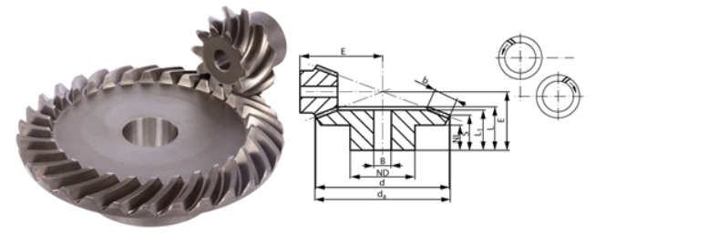

Figure 6 Gear type

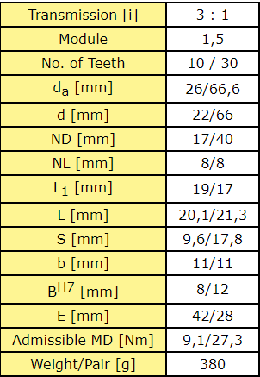

Table 1 Properties of gearing

### Power loss in the bearings

The energy loss in the bearings can also be divided into no-load loss and load dependent loss. The no-load loss in a bearing is mainly caused by the type and size of the bearing, the arrangement of the bearing, and the viscosity and supply of the lubricant (Klaus Michaelis, 2011). **Fout! Verwijzingsbron niet gevonden.** shows the no-load power loss difference between bearing types.

The radial bearing has the lowest no-load loss. Roller bearings with a small taper are suitable for no-load bearing arrangements. When considering the cross load, axial preloading is required, which greatly increases the no-load energy loss of the tapered roller.

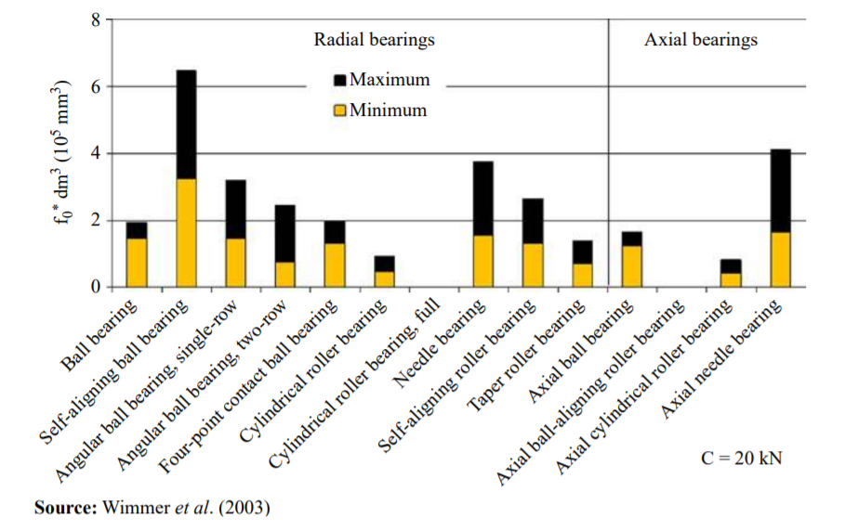

Figure 7 No load loss of bearing

When it comes to load-dependent losses, the causes are different. The load dependent losses depend on bearing type and size, on load and sliding conditions in the bearing and on the lubricant type. **Fout! Verwijzingsbron niet gevonden.** shows load-dependent losses of the bearing with same load capacity C = 20 [kN].

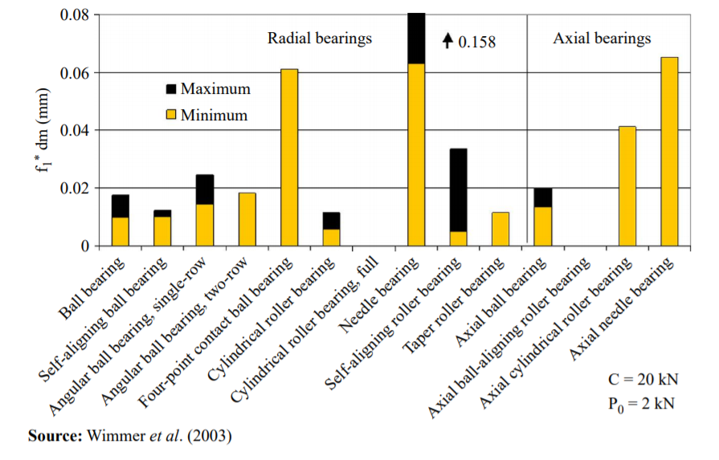

Figure 8 Load-dependent loss of bearing

Cylindrical rollers have the lowest axial power loss. Under the same load, tapered rollers have small energy losses due to their smaller diameter.

The formulas that can be used are as follows:

**Friction force**

$$F_{friction}=F_{load}*µ$$

$F_{friction}$ =loss due to friction [N]

$F_{load}$ =load from axis on bearing [N]

µ=friction coefficient

**Powerloss due to friction**

$$P_{out}=P_{in}-\left(\left(F_{friction}*r_{shaft}\right)*ω\right)$$

$P_{out}$ = output power [W].

= input power [W].

$F_{friction}$ =loss due to friction [N]

$r_{shaft}$ =radius driving shaft [m]

ω=angular velocity [rad/s]

$$T=\frac{60}{2π}×\frac{P}{n}$$

T=torque [Nm].

P=power [W].

n=rotation speed [rpm].

**Friction table**

|  |  |
| --- | --- |
| Bearing Type | Coefficient of friction µ |
| Deep Groove Ball Bearing | 0,0015 |
| Angular Contact Bearing | 0,0020 |
| Cylindrical Roller Bearing, Cage | 0,0010 |
| Cylindrical Roller Bearing, Full Comp. | 0,0020 |
| Tapered Roller Bearing | 0,0020 |
| Spherical Roller Bearing | 0,0020 |
| Ball Thrust Bearing | 0,0015 |
| Cylindrical Roller Thrust Bearing | 0,0050 |
| Tapered Roller Thrust Brg. Cage | 0,0020 |
| Tapered Roller Thrust Brg. Full Comp | 0,0050 |

(FRICTION & FREQUENCY FACTORS, sd)

Table 2 Coefficient of friction with different bearings

### Power loss in shaft

Since power is a function of speed and torque, the speed will not be affected by the length of the shaft, but the torque will. The length of the shaft has an effect on torsional (twisting) stiffness. The longer it is, the less stiff it will be. If the torque on the shaft is varying a lot, then the changes in torque are damped by the deflection of the shaft. If the shaft is under constant torque, the torque loss is almost zero, but in real life the load is not constant. So the length of the shaft will affect the energy loss.

Friction on the shaft can also cause energy loss, so lubricants are needed to help reduce losses caused by friction.

### Power loss in propeller

The propeller is used to generate thrust to overcome the ship resistance. Normally, an open water diagram is used to determine the operational behaviour of the propeller. That is because realistic waters and open waters are rarely the same. Energy loss occurs when the power of the propeller in open water is converted into actual propeller power (Shi1 & Grimmelius, 2009).

## Simulate the resistance caused by wind

Wind is considered an external energy resistance. Since the wind is not fixed and varies from day to day, the researchers found the average wind value of the Dutch sea detected by the testing station. This mean value is used as the input value of the calculation chain.

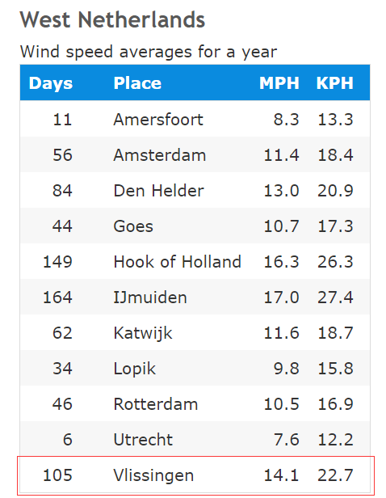

Table 3 Average wind speeds in the Netherlands

(Annual Average Wind Speeds in the Netherlands, 2010)

Table 3 shows the average wind speed for a year in miles per hour [MPH] and kilometres per hour [KPH]. All the numbers here are based on weather data collected from 1981 to 2010.

## Simulation of the resistance caused by waves

A wave is considered an external energy resistance. Since Vlissingen does not have a wave detection point, the researchers decided to use data near Honte nabij Sloehaven as the wave input (Waterinfo-Wave, 2020).

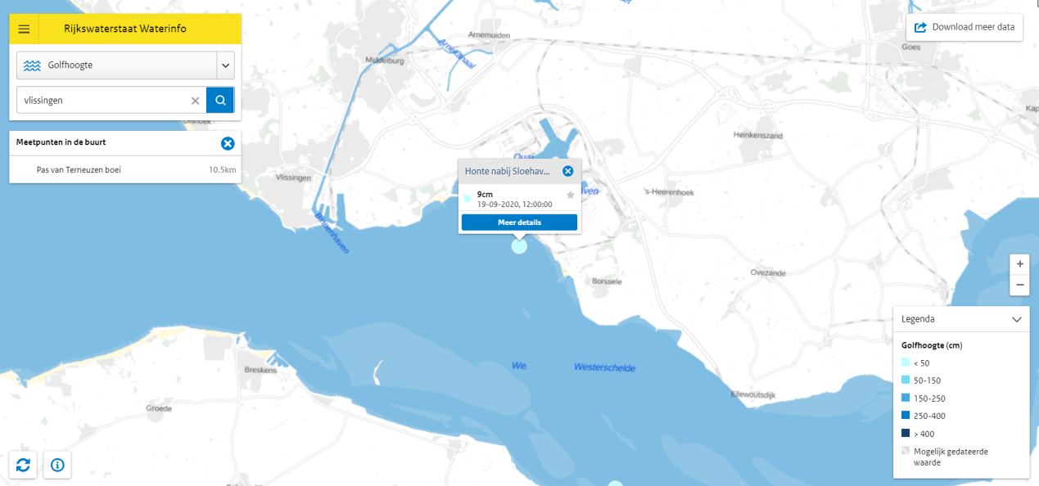

Figure 9 Waterinfo map by Rijkswaterstaat

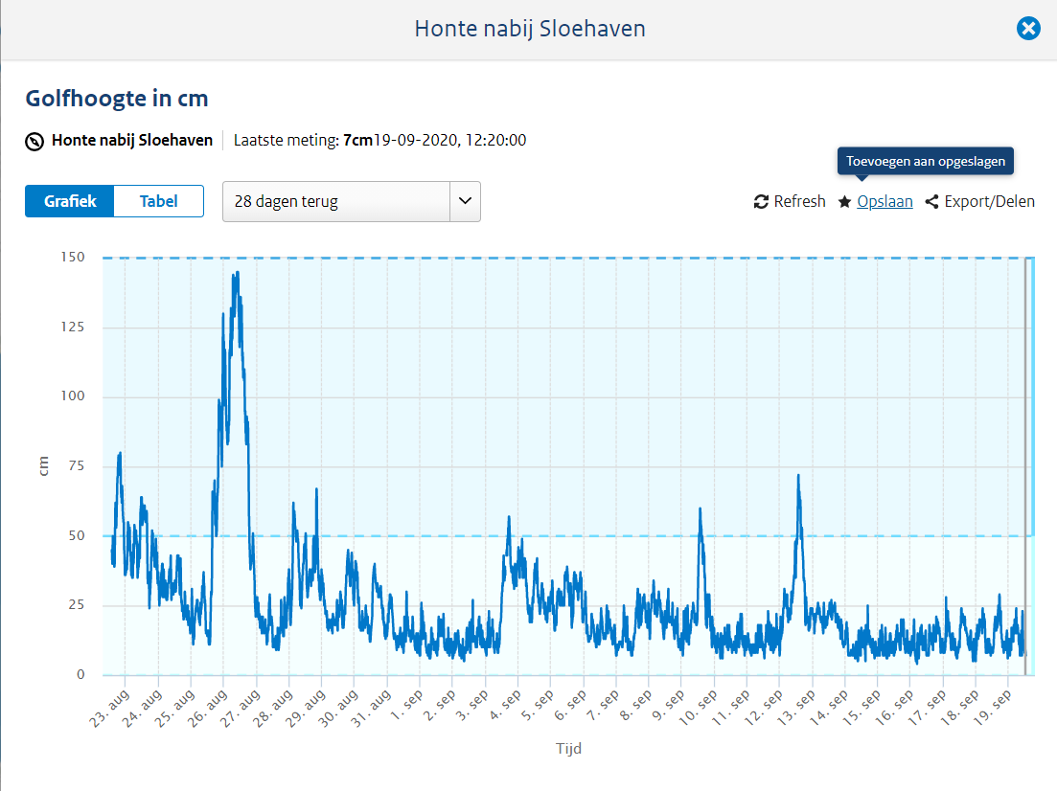

Figure 10 Wave height aug.-sep. in Honte nearby Sloehaven

It can be seen from Figure 10 that the wave data fluctuates greatly, but the data is concentrated around 10cm.

## Simulation of the resistance caused by ocean current

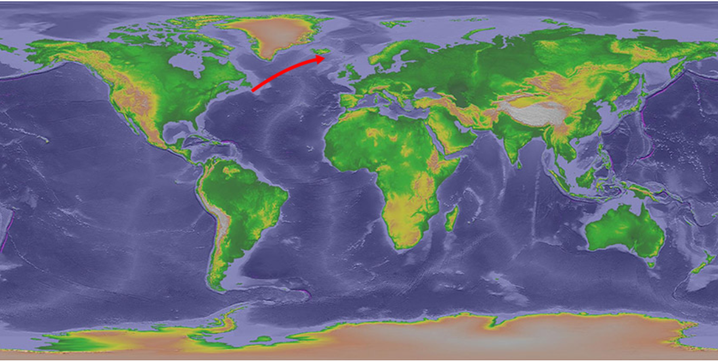

Figure 11 Overview of the water and currents of earth

(Major Ocean Currents, n.d.)

The ocean current surrounding the Netherlands is the North Atlantic Warm Current, the most powerful warm current in the northern Atlantic Ocean and is a continuation of the Gulf Stream. The North Atlantic warm current runs from southwest to northeast (North Atlantic Current). The direction of the ocean current will affect the navigation of the ship. Although the solar boat is driven by a Propeller which is less dependent on ocean currents and winds, all ships can benefit from making good use of ocean currents. According to research, ocean currents in offshore areas can be ignored (Willemsen, 2019).

## Define the output power of a ship's propulsion system

When studying the final output power of the propulsion system, the output power can be calculated by using the following formula.

$$P=F×v$$

P = output power (W)

F = total resistance force (N)

v = boat velocity(m/s)

The thrust required is related to the rotational speed and torque required by the following formula.

$$K_{T}=\frac{Ft}{ρ×n^{2}×d^{4}} → Ft=ρ×n^{2}×d^{4}×K_{T}$$

Ft = thrust (N).

$ρ$ = liquid density (${kg}/{m^{3}}$).

n = rotating speed (rev/s).

d = diameter (m).

$K_{T}$ = thrust coefficient.

## Motor characteristic curve

### Motor drawings and data provided by suppliers

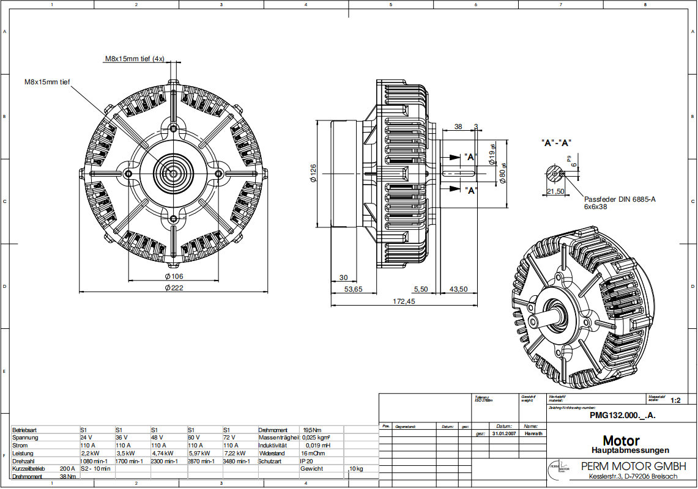

Figure 12 Motor drawing

|  |  |  |
| --- | --- | --- |
| Motor parameters | | |
| Pole pair | Coils | Current | |
| 4 | 20 | 110A | |
| Voltage (V) | Rotation speed (rpm) | Power (kw) | |
| 24 | 1080 | 2,2 | |
| 36 | 1700 | 3,5 | |
| 48 | 2300 | 4,74 | |
| 60 | 2870 | 5,97 | |
| 72 | 3480 | 7,22 | |

Table 4 Motor parameters

The motor datasheet is coupled with multiple graphs for different voltages. These are based upon a data set of different rpms at different loads and voltages. These can be seen below.

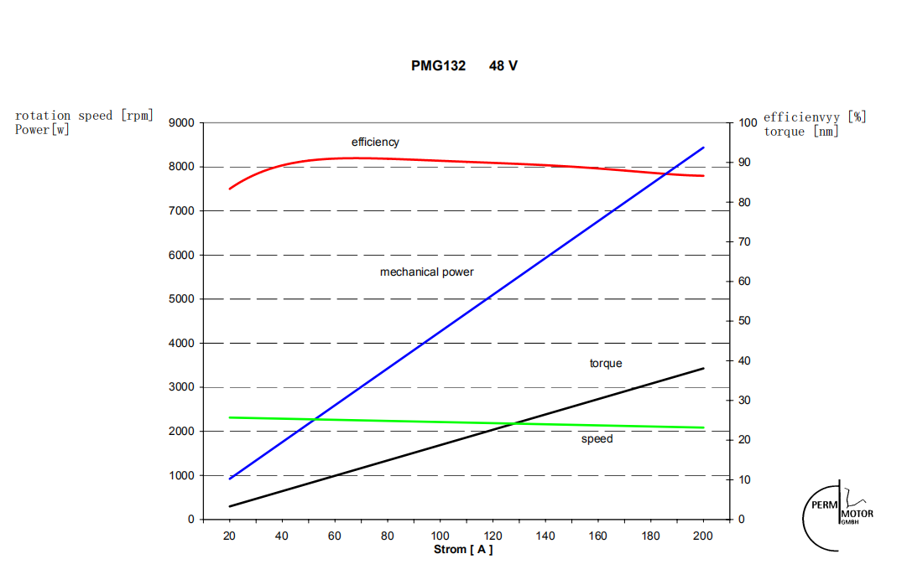

Figure 13 Motor n/P/T-I curve on 48V

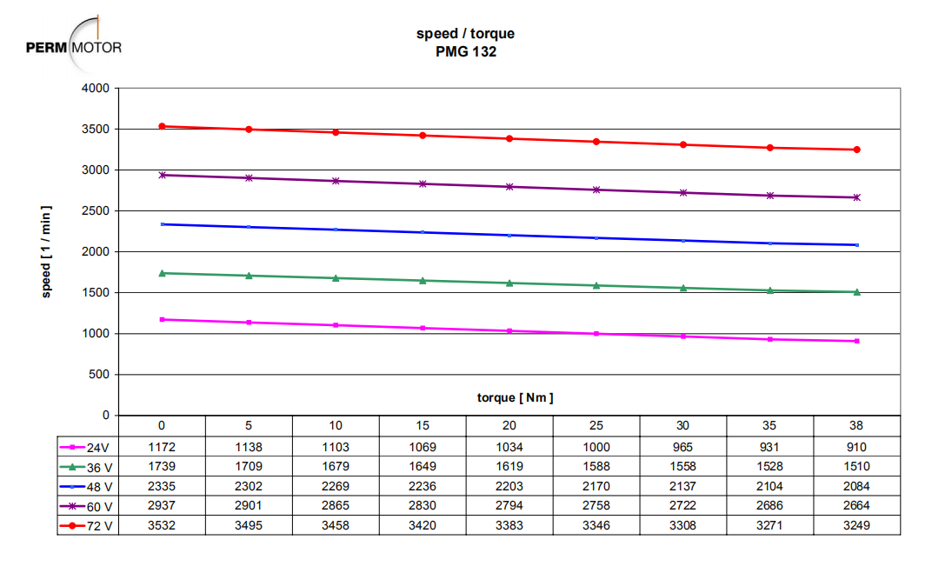

Figure 14 Motor T-n curve on different voltage

This dataset can be expanded linearly, because the lines in the graph above can be estimated as being linear.

$$y-y1=\frac{y2-y1}{x2-x1}*(x-x1)$$

(x, y) = coordinates of interpolation value

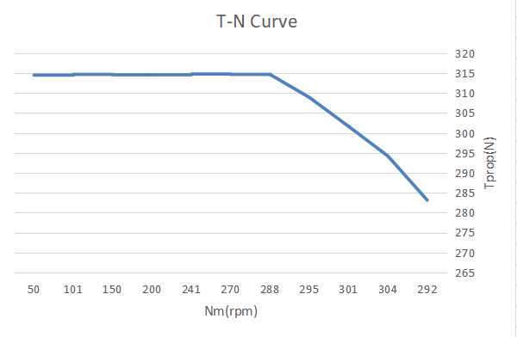

Figure 15 T-N curve of the motor connected to the propellor

## Propeller characteristic curve

The performance of the propeller is usually tested by open water experiments. Normally the performance of the propeller is determined by thrust coefficient ($K_{T}$), torque coefficient ($K_{Q}$) and the advance ratio (J). Researchers can calculate the thrust and torque by using these coefficients. Moreover, the thrust coefficient and torque coefficient are inversely proportional with the advance ratio. When $J=0$, the thrust and torque coefficient reaches their peaks.

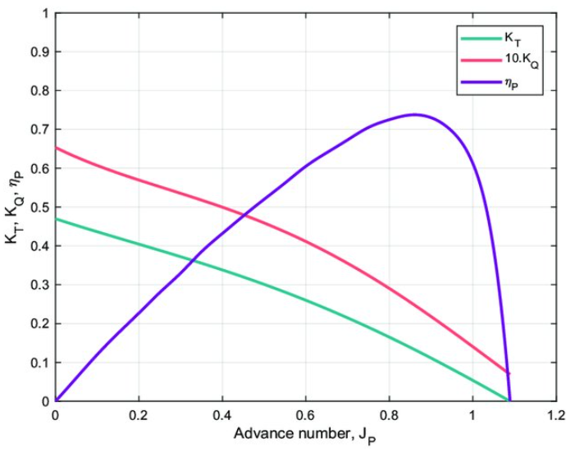

Figure 16 Propeller characteristic curve

$η_{p}$ Represents the efficiency of a propeller in an open water experiment, which is relevant to the thrust coefficient, torque coefficient and advance ratio. The formula of this coefficient will be introduced later.

The main formulas used for the propellor calculation are listed below.

##### Force equilibrium (speed is constant)

$$Ft=Fr$$

Ft = thrust (N).

Fr = resistance (N).

##### Resistance force

$$Rtotal=\left(1-t\right)*Fr$$

Rtotal = total boat resistance (N)

T = thrust deduction factor

Fr = resistance (N).

##### Interpolation formula

(x, y) = coordinates of interpolation value

##### Thrust coefficient

Ft = thrust (N).

= liquid density ().

n = rotating speed (rev/s).

d = diameter (m).

= thrust coefficient.

##### Torque coefficient

*QE = QR – QI*

= torque difference(Nm).

= torque required (Nm).

= torque input (Nm).

= liquid density ().

n = rotating speed (rev/s).

d = diameter (m).

= torque coefficient.

##### Power output

P = output power (W)

F = force (N)

v = velocity(m/s).

##### Power input

P = input power (W)

T = torque (Nm)

ω = radial velocity (rad/s).

##### Stream velocity

Va = inflow stream velocity (m/s)

Vb = boat speed (m/s)

W = wake fraction

##### Propellor efficiency

Ft = thrust (N)

Va = inflow stream velocity (m/s)

N = radial velocity (rad/s)

= torque required (Nm)

##### Propulsive efficiency

Rtotal = total boat resistance (N)

Vb = boat speed (m/s)

N = radial velocity (rad/s)

= torque required (Nm).

##### Required rpm

$$\left.\begin{aligned}P=T*n*\frac{2π}{60} \\ T=Q_{R}=ρ×{(n/60)}^{2}×d^{5}×K_{Q}\end{aligned}\right\}n={\left(\frac{P*{60}^{3}}{ρ*d^{5}*K_{Q}*2π}\right)}^{\frac{1}{3}}$$

P = input power (W)

n = radial velocity (rpm)

T = $Q_{R}$ = torque required (Nm).

$ρ$ = liquid density (${kg}/{m^{3}}$).

d = diameter (m).

$K_{Q}$ = torque coefficient.

# Method

## Overview

The method used in this project is the V-Model method with the main structure shown in **Fout! Verwijzingsbron niet gevonden.**.

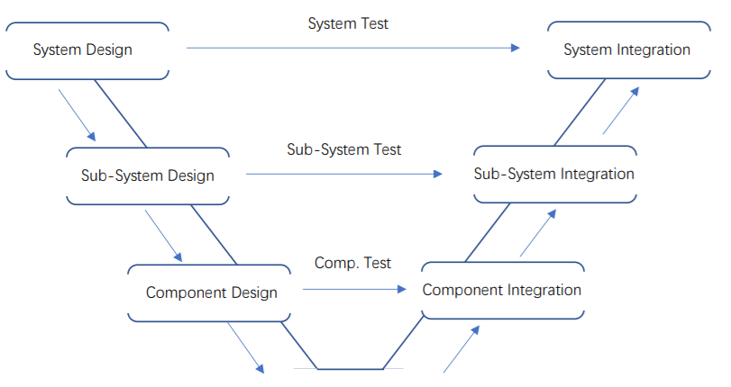

Figure 17 V-model structure

The V-Model can be divided into two main phases: ‘Design Phase’ and ‘Integration Phase’.

In the Design Phase, the behaviours and edges of the final product should be decided and evaluated. In the Integration Phase, focus lies on assembling components, verifying designs in Design Phase and realizing the final product.

The core of V-Model is operating tests and verification. There are several progressive layers in both phases from system to sub-system to component. In the Design Phase different test plans are designed which are used in the corresponding layers in the Integration Phase.

## Reasons of choice

In this propulsion system design project, there is a clear final product idea (fixed component composition, fixed working principle) which gives the team chances to optimize the same idea and guarantee a better functionality of the result. The reason we chose the V-model, is because you do a lot of testing when following the model. Excessive testing is needed to verify our simulation. Especially for this particular propulsion system, every component in every sub-system has close connections. They play different essential roles in the process of generating thrust (components or sub-systems are all related to energy input, output and transmission).

Because every part of the calculation chain has a close connection to each other, we must make sure that the relationship between every part is correct. We must recall and check if there are errors in previous parts before starting a new part. This regularly means going backwards checking for mistakes is necessary. Compared with other methods, the progressive layers of V-Model ensures that the problem and its direction will be recalled and changed effectively. The team can detect the error sources and make targeted improvements easily.

## Usage of method

First, the team has to make the system overview. In order to figure out how system works, disassembling the main system into sub-systems and into components is needed. For every layer, a system description, sub-system descriptions or component descriptions should be taken as the start of the layer. All these descriptions should contain all variables which are related to the input and output of the systems or components. According to these descriptions, the reactions within systems and components can be known and vague elements can be eliminated.

From the system and component descriptions, the design concepts and test plans can be created. In the main system layer, tests will be designed to show the working state of system such as working efficiency and thrust generated by whole propulsion system. In the sub-system layer, tests will be designed, proving relationships between certain sub-systems. For example, the energy transmission/consumption and the power transmission system. In the component layer, the calculation chain will be designed. Tests will be designed to find out the characteristic of every component such as the relationship between the number of gear teeth and the rotation speed.

After finishing all the designs, the components should be reassembled into sub-systems and into a system. The test results from deeper layers will be used in tests from shallower layers. All designs can be validated. When errors appear, the error sources can be found in the corresponding deeper layers.

The following list shows the deliverables of every phase and layer:

|  |  |
| --- | --- |
| Layer | Deliverables |
| Design Phase | |
| System Design | 1. List of demands. 2. Function overview. 3. Analysis of the current situation. 4. System description. 5. System test plan. |
| Sub-System Design | 1. System division. 2. Formula overview. 3. Subsystem description. 4. Subsystem test plan. |
| Component Design | 1. List of components. 2. Component description. 3. Component test plan |
| Integration Phase | |
| Component Integration | 1. Component ordering. 2. Component test. |
| Sub-System Integration | 1. Subsystem assembly plan. 2. Subsystem assembly. 3. Subsystem simulation. |
| System Integration | 1. System assembly plan. 2. System assembly. 3. System test. |

Table 5 Deliverables list in different phases of V-model

# Results

After completing all the design and integration phases following the V-model (appendix 7.1-7.7), a complete overview of the system is created. This contains all the variables, properties and formulas to use as a guideline while developing a simulation of the propulsion system of the Solar Boat.

The project basically had three phases apart from the V-model. During the first part of the project research has been done about propulsion systems and calculations based on that. This is all shown in the V-model “component design” (appendix 7.4). Using all the information and separate calculations, the simulation is build up. This is done with the help of the V-model “integration” (appendix 7.5-7.7). The last step is to simulate and validate the current propulsion system of the Solar Boat, Sealander. For that all the components have been checked and the corresponding properties are inserted in the system.

## Designing

The complete design of the simulation can be depicted in a flowchart containing all the different components and order of calculations. This flowchart is shown below. The arrows give the direction of the data flow. This is used for coupling the calculations into a calculation chain. Different values for different components can be calculated with formulas retrieved from physics.

Each calculation has basically three types of values. The first ones are the variables that are inserted, coming from the user or the previous calculation. The second set of values are the values transmitted back to the user-interface, so the user can read them. The third and last set of values are the values that will be transmitted on to the next component with the corresponding calculations.

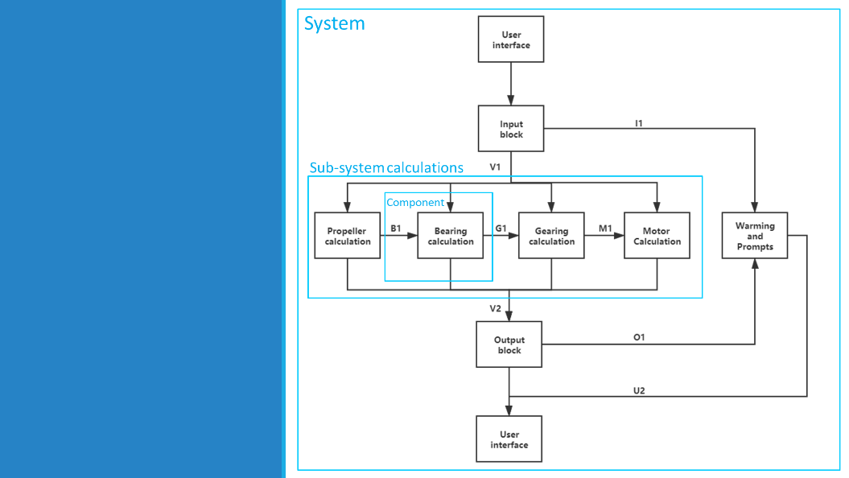

Figure 18 Propulsion simulation system flowchart

## Integrating

After this is all set up individually, the links are being connected into a calculation chain. To interact with the user, a user-interface is designed. This is a user-friendly front panel where only the relevant values are being shown. Therefore the user does not need any technical knowledge to use the simulation. Some relevant values are used to give more insight into the performance of the propulsion system. An example of this are the energy outputs and accompanying graph displayed at the bottom.

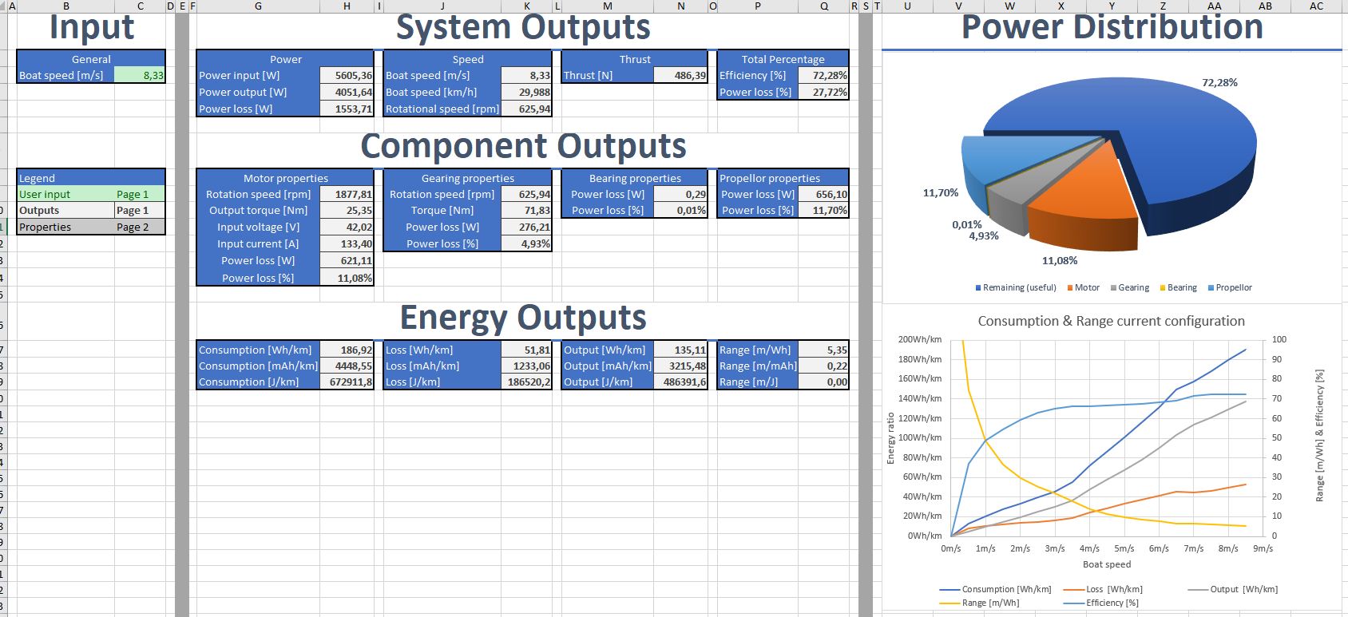

Figure 19 User-interface in simulation

The last step is simulating the current propulsion system and making a digital twin. The properties of the components used in the current propulsion system can be found in the corresponding datasheets. It has also been verified that the datasheets attached belong to the components. There are 4 main physical components; The motor, the transmission (gearing), the bearings, and the propellor.

## Simulating

Verifying the motor was relatively easy, which has been done by comparing the motor nameplates. Attached with the main datasheet were extensive curves showing the load and rotational speed behaviour at different voltages. This dataset was used and expanded using linear inter- and extrapolation. This could be done because the rpm-voltage and rpm-load behaviour is almost linear with a DC motor. This makes swapping the motor easy if the same data array is provided.

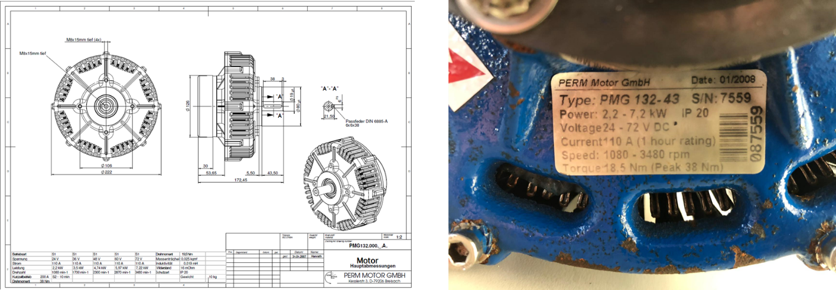

Figure 20 Motor used in the solarboat

The gearing is verified by opening the strut, counting teeth and measuring the diameters. All other properties are either from the datasheet, or using generic standard values. This allows for extensive customizing of the gearing system.

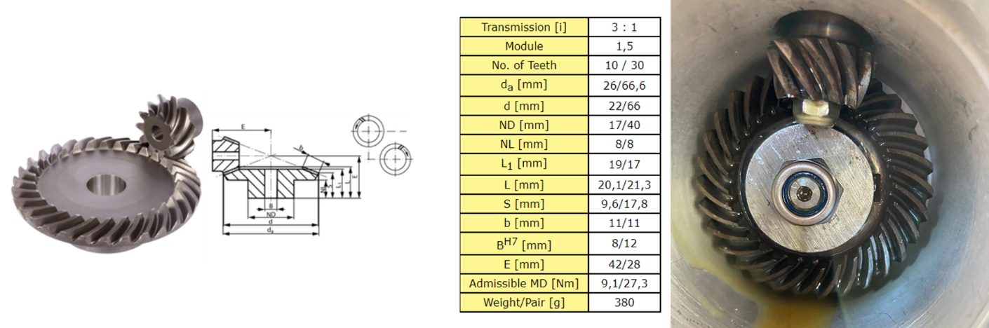

Figure 21 Gearing used in the solarboat

The bearings used in the propulsion system were confirmed by using SOLIDWORKs drawings of the strut. Combined with generic friction coefficients belonging to different bearing types, and an estimation of the load on them, the bearing properties were selected.

The last component is the propellor. Since the propellor used is not labelled with a name or code, it was a little bit harder to verify this component. But by diving into the SolidWorks drawings of the solarboat, information about the propellor was found. Using the diameter and shape, the propellor could be confirmed. Coupled with the propellor, a data array of different propellor properties varying by boat speed was provided.

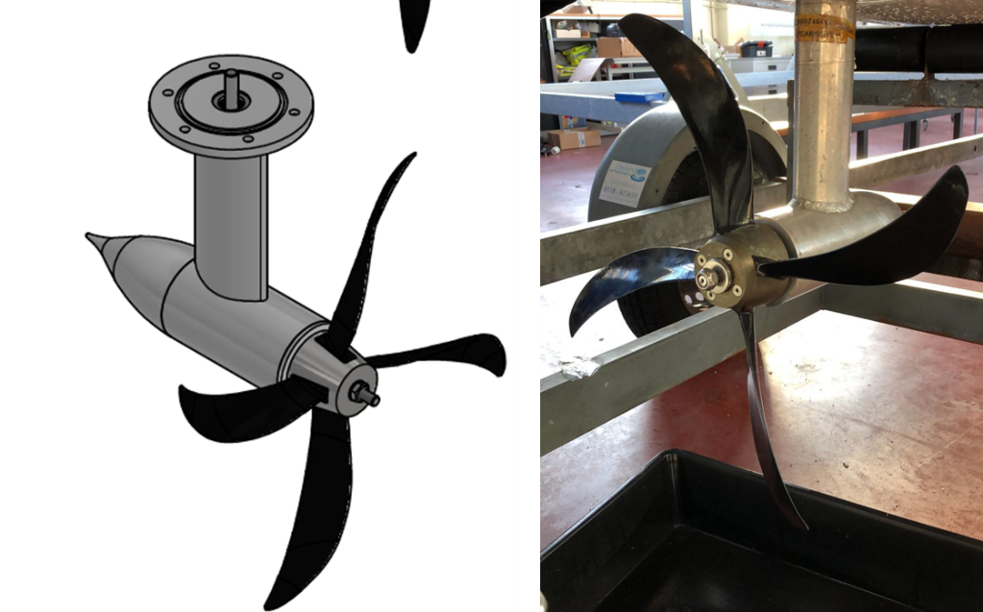

Figure 22 Propeller used in the solarboat

## Validating

Now that all the properties of the different components are determined and inserted into the simulation, calculations can be made. The simulation should be validated with its error margin being less than 10%. The MARIN did a lot of tests years ago and gathered empirical data. This data is stored in this file: *“propdesign_algemene_sheet marof v3 HZ pr”.* A project group from a previous year made calculations with this empirical data and stored them in the same file, under the page: “*propulsion ENG”.* This sheet has some of the same outputs as the simulation so they can be compared and a deviation can be calculated based on that. On the table below is shown how the simulated in-/output power and thrust deviates from the MARIN sheet for different boat speeds. Since none of the deviation is more than 10%, there can be stated that this simulation is valid and very accurate.



Figure 23 Final results validation

# Discussion

## Discrete discussion of results

As seen in chapter 4.4, none of the deviation is more than 10%. This means that all the outputs from the designed simulation are validated and very accurate. Since this is the case, the simulation is ready to be operated.

## Conclusion

The results of the current simulation meet the previous set goal for validation. Therefore, the simulation can be seen as valid and useable. This simulation can thus be used to calculate properties of the solar boat at different speeds. This will help the solar boat project to gain insight into the propulsion system losses and requirements.

## Recommendation

### Physical experiments

First, due to the current pandemic and the maintenance of the solar boat, we could not perform physical experiments on the solar boat to measure the data, so the simulation system was verified based on empirical data from the MAROF sheet. The success of the validation of the simulation system depends on the accuracy of the empirical data and the gearing and motor datasheets. It is recommended to perform physical experiments on the solar boat, such as the initial test that were designed.

The importance of these physical experiments is justified because reality is most always different than the theory. What has been calculated in excel can be different compared to reality due different reasons. One major reason is because the theory could be missing other influences, such as weather disturbances and human error. Another reason could be that the datasheets do not correspond 100% with reality, due to the degradation of components and their performance. To sum up, if the end product is being used in reality, it is preferred that it is also validated using reality.

### Accuracy

Secondly, for improving the accuracy of the simulation, the inclusion of the before mentioned types of influences (weather, human error, degradation of components) could be added. It was not considered for this project, focusing only on the propulsion system of the solar boat under uniform speed and sufficient battery power, but it would add more value to the simulation.

Some of the data given in the empirical data about the motor did not match the data in the motor datasheet, which made the process of building the simulation system complicated and confusing, but eventually we found a suitable solution but could not ensure absolute accuracy, if future researchers want to make the system more accurate than the 5% error, it is recommended to test the solar boat to get the accurate parameters. parameters.

### Simulation limitations & improvements

A main limitation or the current simulation is the exchangeability of different components. The properties don’t give the whole picture of each component. For example, the motor requires a data set to be manually inputted in the motor calculations. Changing the motor would mean changing this data set, along with updating the range of the inter- and extrapolation. This manual change is not very user friendly. This limitation also applies to the gearing, which allows for different parameters to be changed, but an extra conversion or different type of gearing setup is not supported. This might require an update for the different gearing formulas, or addition of parameters.

A more important limitation is the propellor component. This component uses empirical test data of the propellor to calculate its performance. Changing the propellor now would mean changing the whole data set, which has to be generated first. Because of the fact that this data incorporates the hull and pod resistance, a change to these components would also require a revamp of the data set. This could be greatly improved by using open water characteristics derived from flow simulation. If the data set would be automatically generated based on a 3D model of the propellor and boat, the changing of the propellor would be much more user friendly. Such an implementation of flow simulation requires an combination of for example SOLIDWORKS or MATLAB simulations into Excel. This perhaps raises the question of what the desired platform would then be for the simulation. To answer this question, research should be done regarding such implementations and different kinds of simulation programs/languages.

Another limitation of our design in combination with the Excel software, is the fact that the system cannot automatically update the consumption, range & efficiency graph of the system after changing the characteristics of the propulsion system. These characteristics are properties of the motor, gears, bearings, and propeller. This limitation is caused by the fact that the graph uses a set of boat speeds (array) to calculate the curve values. Our design only accounted for 1 value per iteration, and after extensive research, there is no standard function in Excel to simply use an array as an input for one cell and iterate the worksheet based on that array. Such a functionality might be added using the visual basic coding language supported in Excel, but that was out of reach for our project due to time constraints. Another solution would be to use a different platform to perform the simulation. The simulation could be coded in Python, or other programming languages to upgrade the system, making it more user-friendly and practical to use. For updates to the simulation, this will require proper knowledge of these languages.

### Combination of multiple simulations

The researchers of this project focused on the study of the simulated solar boat propulsion system, while the researchers of the second group focussed on the study of the simulated battery system of the solar boat. If the results of both projects were to be combined, the value of the simulation would greatly improve. More accurate time of use of the solar boat can be predicted, along with the ability to find more key improvement points. Especially during the races, complete simulations give a better picture of the different scenarios.

# Bibliography

*Annual Average Wind Speeds in the Netherlands*. (2010). Retrieved from Current Results weather and science facts: https://www.currentresults.com/Weather/Netherlands/wind-speed-annual.php

*Bearing friction coefficient*. (2018, 6 27). Retrieved from https://wenku.baidu.com/view/3b7e69d133d4b14e852468ff.html

*Blade pitch*. (n.d.). Retrieved from wikipedia: https://en.wikipedia.org/wiki/Blade_pitch#cite_note-5

Dalian Maritime University. (2018, 10 10). *Open water Test*. Retrieved from https://wenku.baidu.com/view/b248dd247ed5360cba1aa8114431b90d6d85896e.html

Exhibition, S. M. (2019, 4 29). *Carbon steel density*. Retrieved from https://wenku.baidu.com/view/53b97b2b326c1eb91a37f111f18583d048640f62.html

*FRICTION & FREQUENCY FACTORS*. (n.d.). Retrieved 10 28, 2020, from AMERICAN ROLLER BEARING COMPANY: https://www.amroll.com/friction-frequency-factors.html

*Gear Rolling & Sliding velocity*. (n.d.). Retrieved from https://involute.pro/fileman/Uploads/sliding%20velocity.pdf

*Hardness of general gears*. (2017, 9 20). Retrieved from https://zhidao.baidu.com/question/515963032.html

k.Michaelis&B.-R.Hohn. (n.d.). *Influence of Lubricants on Power Loss of Cylindrical Gears.* Retrieved from Taylor and Francis Online: https://www.tandfonline.com/doi/abs/10.1080/10402009408983279

Klaus Michaelis, B.-R. H. (2011). *Influence factors on gearbox power loss.* Retrieved from https://mediatum.ub.tum.de/doc/1323611/file.pdf

Lauer, D. A. (2013). *Gear Lubrication.* Retrieved from Encyclopedia of Tribology: https://link.springer.com/referenceworkentry/10.1007%2F978-0-387-92897-5_19#howtocite

Lin Zou, M. D. (2018, 6). *Numerical Simulation of the Churning Power.* Retrieved from Wuhan University of Technology: https://pdfs.semanticscholar.org/ef43/b4a9f1f400e9fefe3b8d3c2f5841b9e99c18.pdf

*Major Ocean Currents*. (n.d.). Retrieved from national weather servies: https://www.weather.gov/jetstream/currents_max

*North Atlantic Current*. (n.d.). Retrieved from wikipedia: https://en.wikipedia.org/wiki/North_Atlantic_Current#:~:text=The%20NAC%20flows%20northward%20east,crosses%20the%20Mid%2DAtlantic%20Ridge.

Shi1, W., & Grimmelius, D. S. (2009). *Analysis of energy conversion in ship*. Retrieved from https://www.witpress.com/Secure/elibrary/papers/ESUS09/ESUS09041FU1.pdf

*Standard gear tooth number*. (2019, 9 8). Retrieved from https://zhidao.baidu.com/question/162747752.html

*Viscosity index*. (n.d.). Retrieved from wikipedia: https://en.wikipedia.org/wiki/Viscosity_index

*Waterinfo-Wave*. (2020, 9 19). Retrieved from waterinfo: https://waterinfo.rws.nl

Willemsen, D. (2019, April 7). *Currents*. Retrieved from Currents & Navigation: https://www.sailingissues.com/navcourse8.html

# Appendices

## V-model design phase (demo)

### Demo test plan

#### Aim & Hypothesis

**Aim**The aim of this test is to let the client use the simulation interface to calculate different aspects of the propulsion system.

**Hypothesis**

The client can use this validated simulation to design an improved the propulsion system.

#### Variables

These are the constants and variables that will be used during the test. The constants are the same for both situations and define the testing environment.

We will be testing two situations to check the borders of the system. The first situation is a situation where normal values will be put in, between the stated limits. For the second situation we stress the system a bit and put in exceptional values and show how the simulation will react on that.

|  |  |
| --- | --- |
| Constants | Keep constant at... |
| Ambient temperature | Standard indoor temperature with lower and upper limits (20 ℃ ± 5℃). |
| Battery level computer | Constant power source. |
| Software Excel | Newest version. |
| All input variables | Real positive numbers & ISO-notation. |
| Properties | Same as MAROF sheet [worksheet ENG]. |

Table 6 Constants demo test

**Common situation**

The limits stated are the limits of the real world. If values are put in out of this range, the outputs will be unreliable.

|  |  |
| --- | --- |
| Inputs | Value |
| Boat speed [m/s] | Change value from 0 to 2 to 4,56 to 8 |

Table 7 Inputs common situation

**Unusual situation**

|  |  |
| --- | --- |
| Inputs | Value |
| Boat speed [m/s] | Input the letter ‘h’ |
| Beat speed [m/s] | -100.000 |
| Gear addendum radius [m] | Input the letter ‘f’ |
| Gear addendum radius [m] | -8 |
| Liquid density [kg/m^3] | Input the letter ‘g’ |
| Liquid density [kg/m^3] | -200 |

Table 8 Inputs unusual situation

**Outputs**

The outputs monitored will be the same for both situations and will be used to see variations or changes in the system.

|  |  |
| --- | --- |
| Outputs | Value |
| Thrust [N] | Indicator between 0 & 500 |
| Power input [W] | Indicator between 0 & 6000 |
| Power output [W] | Indicator between 0 & 4100 |
| Propellor speed [rpm] | Indicator between 0 & 640 |

Table 9 Outputs monitored

#### Tools

Below are the tools listed that will be used during this test.

|  |  |
| --- | --- |
| Testing tools | Demand |
| Computer | Windows 10 compatible |
| Excel | Newest version. |
| Keyboard | No limit. |
| Mouse | No limit. |

Table 10 Testing tools

#### Method

This section consists of actions that need to be performed during the test in order to conclude a result. The conditions of the constants stated in chapter “2. Variables” have to be met before executing the simulation. To execute the simulation, follow the steps stated in “4.1. Steps”.

To validate our design, we can compare it to the datasheet: “propdesign_algemen_sheet marof v3 HZ [worksheet propulsion ENG]”. This is a datasheet with a lot of empirical data retrieved from testing and calculations based on that. This is performed by the MAROF, which is the study: Marine Officer. This data is carefully retrieved so we can use this data to validate our simulation.

The boat is not available for testing, so therefore we use data from a sheet instead of building a test setup and measuring data from that.

**Steps**

1. Power up the laptop and open Microsoft Excel.
2. Load in the: “Propulsion system simulation” file in Excel.
3. Modify the value of the different inputs.
4. Perform a simulation for every input value modification.
5. Load in the: “propdesign_algemen_sheet marof v3 HZ” file in Excel.
6. Compare the results with the empirical data from the MAROF sheet.
7. Close Excel.

#### Expected results

The expected results of the outputs are as followed.

The outputs from the simulation is within a 10% deviation from the corresponding outputs on the MAROF sheet mentioned above, while inserting the same boat speeds.

We also expect successful prompts.

#### Conclusion

When boat speed is being changed within the given range, the output values are changing accordingly within 10% deviation of the MAROF sheet, we then consider the test as reliable and passed.

When the outputs are more than 10% deviation, we consider that it failed the test.

When the inputs are like stated at “2.2 Unusual situation” (out of range or incorrect values) and the system does give warnings, we consider that it passes the test.

## V-model design phase (system)

### System description

#### Flowchart

Figure 24 Flowchart system

**Unique identifiers**

|  |  |
| --- | --- |
| Unique ID | Long Name |
| U1 | User input |
| U2 | Simulation output |
| O1 | Impact to environment |
| O2 | Impact from environment |

Table 11 Unique identifiers system

#### Table of limits

|  |  |  |  |  |
| --- | --- | --- | --- | --- |
| Interaction | Symbol | Min. | Max. | Unit |
| -> U1 | | | | |
| User input | | | | |
| Boat speed | $$v_{boat}$$ | 0 | 8,5 | m/s |
| <- U2 | | | | |
| Simulation output | | | | |
| Thrust | $$F_{T}$$ | 0 | 500 | N |
| Boat velocity | $$V$$ | 0 | 30 | Km/h |
| Rotational speed propeller | $$n_{P}$$ | 0 | 2300 | rpm |
| Power input | $$P_{input}$$ | 0 | 6000 | W |
| Power output | $$P_{output}$$ | 0 | 4100 | W |
| Power loss |  | 0 | 810 | W |
| Current required | I | 0 | 250 | A |
| Voltage required | U | 0 | 72 | V |
| Efficiency |  | 0 | 100 | % |
| Prompts for successful simulation | - | Simulate successfully | | - |
| Warnings for unsuccessful simulation | - | Simulate unsuccessfully | | - |
| Prompts for how to optimize unsuccessful simulation | *-* | Input error. Input values should be numeric. | | - |
| -> O1 | | | | |
| Impact to the environment | | | | |
| Heat | $$Q_{heat}$$ | Will not be considered in the design | | W |
| Noise | $$N_{noise}$$ | dB |
| <- O2 | | | | |
| Impact from environment | | | | |
| Temperature | $$T_{E}$$ | Will not be considered in the design | | $$℃$$ |
| Humidity | $$H_{E}$$ | %RH |

Table 12 Table of limits system

#### Table of properties

|  |  |  |  |  |
| --- | --- | --- | --- | --- |
| Generator | Symbol | Min. | Max. | Unit |
| User interactions | | | | |
| Motor subsystem | | | | |
| Motor properties | *Will not be considered in the design.* | | | |
| Motor data array (U-T) | $$n_{motor}$$ | 0 | 5000 | rpm |
| Current-Torque coefficient | $$ct$$ | 0 | 100 | - |
| Shaft subsystem | | | | |
| Shaft density (Exhibition, 2019) | *Will not be considered in the design.* | | | |
| Diameter |
| Length |
| Shaft torsional stiffness |
| Bearing subsystem | | | | |
| Type | *Will not be considered in the design.* | | | |
| Inner diameter |
| Outer diameter |
| Friction |
| Friction coefficient (Bearing friction coefficient, 2018) | $$µ_{bearing}$$ | $$1,5*{10}^{-3}$$ | $$5*{10}^{-3}$$ | - |
| Seal coefficient | $$µ_{seal}$$ | $$1,5*{10}^{-3}$$ | $$5*{10}^{-3}$$ | - |
| Load | $$F$$ | 0 | 1000 | N |
| Shaft radius | $$r_{shaft}$$ | 0 | 0,05 | m |
| Gearing subsystem | | | | |
| Gear material hardness (Hardness of general gears, 2017) | *Will not be considered in the design.* | | | |
| Diameter |
| Tooth shape |
| Friction coefficient | $$µ_{gear}$$ | 0,1 | 0,15 | - |
| Ratio | $$R_{g}$$ | 0,1 | 10 | # |
| Index circle pressure angle | $$α$$ | 15 | 25 | ° |
| Index circle diameter of driving wheel | $$d$$ | 0 | - | m |
| Addendum radius | $$d_{1}$$ | 0 | - | m |
| Deddendum radius | $$d_{2}$$ | 0 | - | m |
| Lubricant viscosity (Viscosity index) | $$μ$$ | 0 | - | mm^2/s |
| Tooth number (Standard gear tooth number, 2019) | $$z$$ | 0 | - | - |
| Modulus | $$m$$ | 0 | - | - |
| Lubricant density | $$ρ$$ | 0 | - | $$g/{m^{3}}$$ |
| Immersion depth ratio | $$h$$ | 0 | - | # |
| Tooth width ratio | $$b$$ | 0 | - | # |
| Propeller subsystem | | | | |
| Diameter | $$d_{prop}$$ | 0,1 | 0,5 | m |
| Thrust deduction coefficient | $$t$$ | 0 | 1 | - |
| Wake fraction coefficient | $$w$$ | 0 | 1 | - |
| Liquid density (water) | $$ρ$$ | 980 | 1000 | Kg/m^3 |
| Propeller properties table:  Changing according to Vb. | $$R_{total}$$ | 0 | 500 | N |
| $$η$$ | 0 | 100 | % |
| $$K_{T}$$ | 0 | 1 | - |
| $$K_{Q}$$ | 0 | 1 | - |
| User interface subsystem | | | | |
| User interface properties | *Will not be considered in the design.* | | | |
| Environmental impacts | | | | |
| Air thermal coefficient | *Will not be considered in the design.* | | | |
| Airpressure |
| Heat |
| Noise |
| Temperature |
| Humidity |

Table 13 Table of properties system

### System test plan

#### Aim & Hypothesis

**Aim**

The aim of this test is to verify the simulation of the propulsion system of the Solar boat.

**Hypothesis**

The simulation will be verified according to the performed tests.

#### Variables

These are the constants and variables that will be used during the test.

|  |  |
| --- | --- |
| Constants simulation | Keep constant at... |
| Ambient temperature | Standard indoor temperature with lower and upper limits (20 ℃ ± 5℃). |
| Battery level computer | Constant power source. |
| Software Excel | Newest version. |
| All input variables | Real positive numbers & ISO-notation. |
| Properties | Same as MAROF sheet [worksheet ENG]. |

Table 14 Constants system test

**Inputs**

The limits stated are the limits of the real world. If values out of this range are entered, the outputs will be unreliable.

|  |  |
| --- | --- |
| Inputs | Value |
| Boat speed [m/s] | Change value between 0 & 8,5. |

Table 15 Inputs system

**Outputs**

These are the outputs that will be monitored and will be used to see variations or changes in the system.

|  |  |
| --- | --- |
| Outputs | Value |
| Thrust [N] | Indicator between 0 & 500 |
| Power input [W] | Indicator between 0 & 6000 |
| Power output [W] | Indicator between 0 & 4100 |
| Prompts or warnings for successful or failed simulation | Simulate successfully / unsuccessfully |

Table 16 Outputs monitored

#### Tools

|  |  |
| --- | --- |
| Testing tools | Demand |
| Computer | Windows 10 compatible |
| Excel | Newest version |
| Keyboard | No limit |
| Mouse | No limit |
| Calculator | Basic calculator |
| Pen & Paper | Basic pen & paper |

Table 17 Testing tools system

#### Method

This section consists of actions that need to be performed during the test in order to conclude a result. The conditions of the constants stated in chapter “2. Variables” have to be met before executing the simulation. To execute the simulation, follow the steps stated in “4.1. Steps”.

To validate our design, we can compare it to the datasheet: “propdesign_algemen_sheet marof v3 HZ [worksheet propulsion ENG]”. This is a datasheet with a lot of empirical data retrieved from testing and calculations based on that. This is performed by the MAROF, which is the study: Marine Officer. This data is carefully retrieved so we can use this data to validate our simulation.

The boat is not available for testing, so therefore we use data from a sheet instead of building a test setup and measuring data from that.

**Steps**

1. Set up computer and load in simulation.
2. Insert different boat speeds.
3. Run the simulation for every boat speed.
4. Compare results with the corresponding outputs on the excel datasheet.

#### Expected results

The expected results of the outputs are as followed.

The outputs from the simulation is within a 10% deviation from the corresponding outputs on the MAROF sheet mentioned above, while inserting the same boat speeds.

We also expect successful prompts.

#### Conclusion

When boat speed is being changed within the given range, the output values are changing accordingly within 10% deviation of the MAROF sheet, we then consider the test as reliable and passed.

When the outputs are more than 10% deviation, we consider that it failed the test.

## V-model design phase (sub-system)

### Subsystem description (user interface)

#### Flowchart

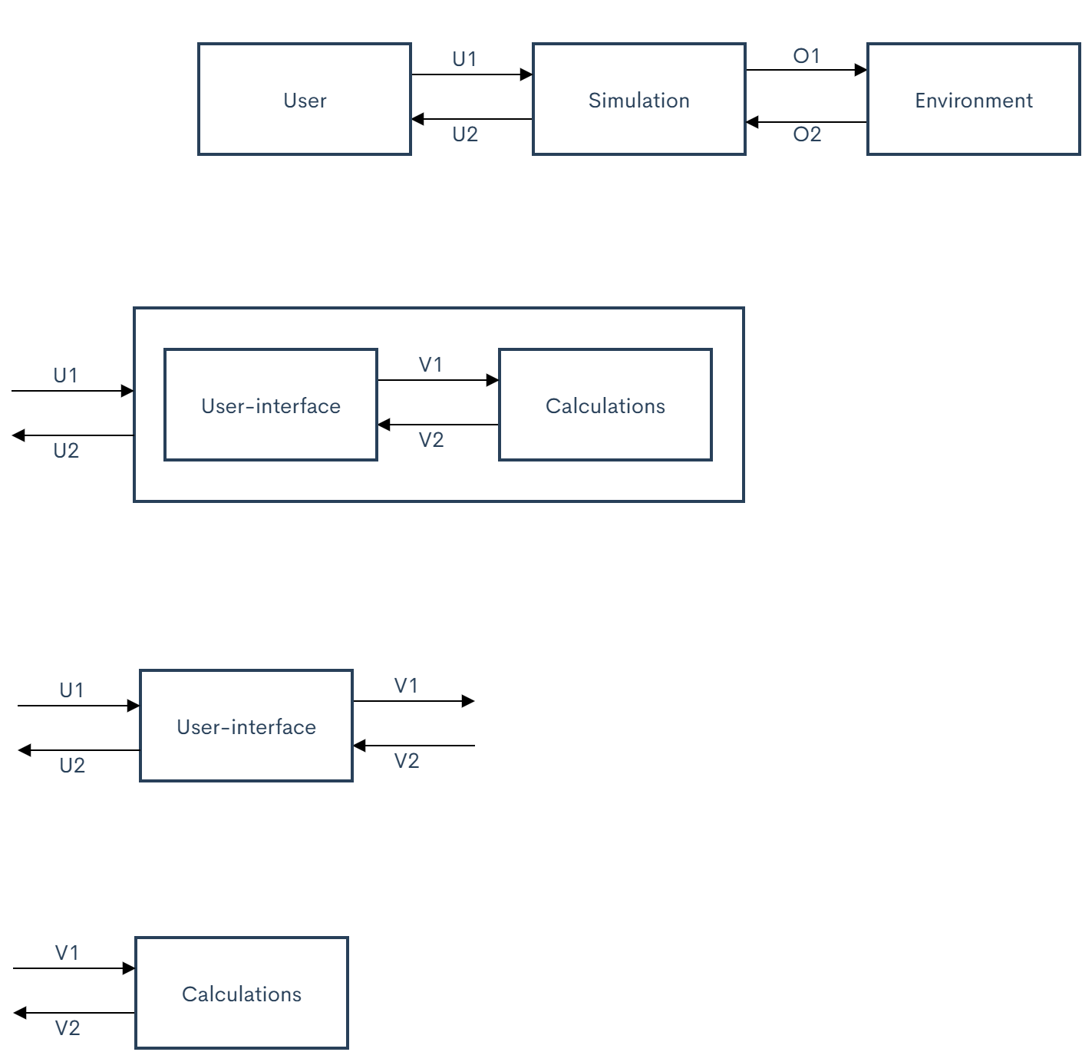

Figure 25 Flowchart user-interface

#### Unique identifiers

|  |  |
| --- | --- |
| Unique ID | Long Name |
| U1 | User input |
| U2 | Simulation output |
| V1 | User-interface sub-system output |
| V2 | Calculation sub-system output |

Table 18 Unique identifiers user-interface

#### Table of limits

|  |  |  |  |  |  |  |
| --- | --- | --- | --- | --- | --- | --- |
| Interaction | Symbol | | Min. | Max. | Unit | |
| -> U1 | | | | | | |
| *Data from normal users* | | | | | | |
| Limit input | | | | | | |
| Boat speed | $$v_{boat}$$ | | 0 | 8,5 | m/s | |
| *Data from administrators* | | | | | | |
| Properties input (used to set up calculation) | | | | | | |
| Motor data array (U-T) | $$n_{motor}$$ | | 0 | 5000 | rpm | |
| Motor current-torque coefficient | $$ct$$ | | 0 | 100 | - | |
| Bearing friction coefficient |  | |  |  | - | |
| Bearing seal coefficient |  | |  |  | - | |
| Bearing load |  | | 0 | 1000 | N | |
| Bearing shaft radius |  | | 0 | 0,05 | m | |
| Gear friction coefficient |  | | 0,1 | 0,15 | - | |
| Gear transmission ratio |  | | 0,1 | 10 | # | |
| Gear index circle pressure angle |  | | 15 | 25 |  | |
| Gear index circle diameter of driving wheel |  | | 0 | - | m | |
| Gear addendum radius |  | | 0 | **-** | m | |
| Gear dedendum radius |  | | 0 | - | m | |
| Gear tooth number |  | | 0 | **-** | **-** | |
| Gear tooth width ratio |  | | 0 | - | # | |
| Gear modulus |  | | 0 | - | - | |
| Gear immersion depth ratio |  | | 0 | - | # | |
| Gear lubricant viscosity |  | | 0 | **-** | mm^2/s | |
| Gear lubricant density |  | | 0 | - |  | |
| Propellor diameter |  | | 0,1 | 0,5 | m | |
| Propellor thrust deduction coefficient |  | | 0 | 1 | - | |
| Propellor wake fraction coefficient |  | | 0 | 1 | - | |
| Propellor liquid density (water) | $$ρ$$ | | 980 | 1000 | Kg/m^3 | |
| Propeller properties table:  Changing according to Vb. | $$R_{total}$$ | | 0 | 500 | N | |
| $$η$$ | | 0 | 100 | % | |
| $$K_{T}$$ | | 0 | 1 | - | |
| $$K_{Q}$$ | | 0 | 1 | - | |
| <- U2 | | | | | | |
| *Data to normal users and administrators* | | | | | | |
| Limit output | | | | | | |
| Thrust | $$F_{T}$$ | | 0 | 500 | N | |
| Boat velocity | $$V$$ | | 0 | 30 | Km/h | |
| Rotational speed propeller |  | | 0 | 2300 | rpm | |
| Power input | $$P_{input}$$ | | 0 | 6000 | W | |
| Power output | $$P_{output}$$ | | 0 | 4100 | W | |
| Power loss |  | | 0 | 810 | W | |
| Current required | I | | 0 | 250 | A | |
| Voltage required | U | | 0 | 72 | V | |
| Efficiency |  | | 0 | 100 | % | |
| Prompts for successful simulation | - | *Simulate successfully* | | | | - |
| Warnings for unsuccessful simulation | - | *Simulate unsuccessfully* | | | | - |
| Prompts for how to optimize unsuccessful simulation | *-* | *Input error. Input values should be numeric.* | | | | - |

Table 19 Table of limits user-interface

|  |  |  |  |  |
| --- | --- | --- | --- | --- |
| Interaction | Symbol | Min. | Max. | Unit |
| <- V1 | | | | |
| *Data to calculation sub-system* | | | | |
| Limit output | | | | |
| Boat speed | $$v_{boat}$$ | 0 | 8,5 | m/s |
| Properities output (used to set up calculation) | | | | |
| Motor data array (U-T) | $$n_{motor}$$ | 0 | 5000 | rpm |
| Motor current-torque coefficient | $$ct$$ | 0 | 100 | - |
| Bearing friction coefficient |  |  |  | - |
| Bearing seal coefficient |  |  |  | - |
| Bearing load |  | 0 | 1000 | N |
| Bearing shaft radius |  | 0 | 0,05 | m |
| Gear friction coefficient |  | 0,1 | 0,15 | - |
| Gear transmission ratio |  | 0,1 | 10 | # |
| Gear index circle pressure angle |  | 15 | 25 |  |
| Gear index circle diameter of driving wheel |  | 0 | - | m |
| Gear addendum radius |  | 0 | **-** | m |
| Gear dedendum radius |  | 0 | - | m |
| Gear tooth number |  | 0 | **-** | **-** |
| Gear tooth width ratio |  | 0 | - | # |
| Gear modulus |  | 0 | - | - |
| Gear immersion depth ratio |  | 0 | - | # |
| Gear lubricant viscosity |  | 0 | **-** | mm^2/s |
| Gear lubricant density |  | 0 | - |  |
| Propellor diameter |  | 0,1 | 0,5 | m |
| Propellor thrust deduction coefficient |  | 0 | 1 | - |
| Propellor wake fraction coefficient |  | 0 | 1 | - |
| Propellor liquid density (water) | $$ρ$$ | 980 | 1000 | Kg/m^3 |
| Propeller properties table:  Changing according to Vb. | $$R_{total}$$ | 0 | 500 | N |
| $$η$$ | 0 | 100 | % |
| $$K_{T}$$ | 0 | 1 | - |
| $$K_{Q}$$ | 0 | 1 | - |
| -> V2 | | | | |
| *Data from calculation sub-system* | | | | |
| Limit input | | | | |
| Thrust | $$F_{T}$$ | 0 | 500 | N |
| Boat velocity | $$V$$ | 0 | 30 | Km/h |
| Rotational speed propeller | $$n_{P}$$ | 0 | 2300 | rpm |
| Power input | $$P_{input}$$ | 0 | 6000 | W |
| Power output | $$P_{output}$$ | 0 | 4100 | W |
| Power loss | $$P_{loss}$$ | 0 | 810 | W |
| Current required | I | 0 | 250 | A |
| Voltage required | U | 0 | 72 | V |
| Efficiency | $$η$$ | 0 | 100 | % |

Table 20 Table of properties user-interface

### Subsystem test plan (user interface)

#### Aim & Hypothesis

**Aim**

The aim of this test is to verify the user interface of the propulsion system of the Solar boat.

**Hypothesis**

The user interface will be verified according to the performed tests.

#### Variables

These are the constants and variables that will be used during the test.

|  |  |
| --- | --- |
| Constants simulation | Keep constant at... |
| Ambient temperature | Standard indoor temperature with lower and upper limits (20 ℃ ± 5℃). |
| Battery level computer | Constant power source. |
| All input variables | Real positive numbers & ISO-notation. |

Table 21 Constants user-interface

**Normal** **Input**

The limits stated are the limits of the real world. If values out of this range are entered, the outputs will be unreliable.

|  |  |
| --- | --- |
| Inputs | Value |
| Boat speed [m/s] | A numeric number |
| Properties setting values | Nonzero numeric numbers |

Table 22 Normal inputs user-interface

**Unusual Input**

|  |  |
| --- | --- |
| Inputs | Value |
| Boat speed [m/s] | A non-numeric symbol or a letter |
| Properties setting values | Zeros or non-numeric symbols or letters |

Table 23 Unusual input user-interface

**Outputs**

These are the outputs that will be monitored and will be used to see variations or changes in the system.

|  |  |
| --- | --- |
| Outputs | Value |
| Prompts for successful simulation | - |
| Warning for unsuccessful simulation and wrong inputs | - |

Table 24 Outputs monitored user-interface

#### Tools

|  |  |
| --- | --- |
| Testing tools | Demand |
| Computer | Windows 10 compatible |
| Excel | Newest version |
| Keyboard | No limit |
| Mouse | No limit |
| Calculator | Basic calculator |
| Pen & Paper | Basic pen & paper |

Table 25 Testing tools user-interface

#### Method

This section consists of actions that need to be performed during the test to conclude a result. The conditions of the constants stated in chapter “2. Variables” have to be met before executing the simulation. To execute the simulation, follow the steps stated in “4.1. Steps”.

This test will use an independent part which has no relationship with the calculation sub-system which will be used in the final design. We create a new calculation part to check if user-interface sub-system can give correct prompts or waring in different situations.

**Steps**

1. Set properties first, give all properties nonzero and numeric values.
2. Input a numeric boat speed. Record the message box result.
3. Input a non-numeric value to boat speed. Record the message box result.
4. Change one of the properties into a non-numeric value of zero. Record the message box result.
5. Input a random boat speed (no matter what type the input is). Record the message box result.

#### Expected results

The expected results of the outputs are as followed.

With normal inputs, after changing the input boat speed, there should be message boxes with a prompt: Successful simulation.

With unusual inputs, after changing the input boat speed, there should be message box with WARNING in it. And there are following situations:

|  |  |  |  |
| --- | --- | --- | --- |
| Properties | Boat speed | Message box outputs (In input-output sheet) | Message box outputs (In properties setting sheet) |
| With zero values | No matter what types of value it is. | WARNING: Input error. All property inputs shouldn't be zero | WARNING: Simulation can't be processed. There should be no zero or unumerice value in properties setting |
| With non-numeric values | WARNING: Input error. All property inputs should be numeric |
| With numeric values | With non-numeric values | - | WARNING: Input error. Input should be a numeric number |
| With numeric values | Successful simulation |

Table 26 Expected results user-interface test

#### Conclusion

When we input different boat speeds and properties, there are corresponding prompts and waring message boxes which follow the list in desired results. We state the tests successful.

If the output message boxes have results which are not mentioned in the desired results list, we state the tests failed.

### Subsystem description (calculations)

#### Flowchart

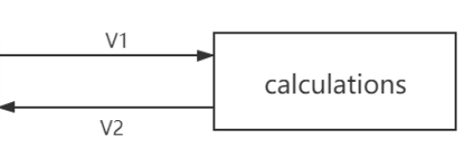

Figure 26 Flowchart calculations

#### Unique identifiers

|  |  |
| --- | --- |
| Unique ID | Long Name |
| V1 | User-interface sub-system output |
| V2 | Calculation sub-system output |

Table 27 Unique identifiers calculations

#### Table of limits

|  |  |  |  |  |
| --- | --- | --- | --- | --- |
| Interaction | Symbol | Min. | Max. | Unit |
| -> V1 | | | | |
| Data from user interface sub-system | | | | |
| Limit input | | | | |
| Boat speed | $$v_{boat}$$ | 0 | 8,5 | m/s |
| Properities input (used to set up calculation) | | | | |
| Motor data array (U-T) | $$n_{motor}$$ | 0 | 5000 | rpm |
| Motor current-torque coefficient | $$ct$$ | 0 | 100 | - |
| Bearing friction coefficient |  |  |  | - |
| Bearing seal coefficient |  |  |  | - |
| Bearing load |  | 0 | 1000 | N |
| Bearing shaft radius |  | 0 | 0,05 | m |
| Gear friction coefficient |  | 0,1 | 0,15 | - |
| Gear transmission ratio |  | 0,1 | 10 | # |
| Gear index circle pressure angle |  | 15 | 25 |  |
| Gear index circle diameter of driving wheel |  | 0 | - | m |
| Gear addendum radius |  | 0 | **-** | m |
| Gear dedendum radius |  | 0 | - | m |
| Gear tooth number |  | 0 | **-** | **-** |
| Gear tooth width ratio |  | 0 | - | # |
| Gear modulus |  | 0 | - | - |
| Gear immersion depth ratio |  | 0 | - | # |
| Gear lubricant viscosity |  | 0 | **-** | mm^2/s |
| Gear lubricant density |  | 0 | - |  |
| Propellor diameter |  | 0,1 | 0,5 | m |
| Propellor thrust deduction coefficient |  | 0 | 1 | - |
| Propellor wake fraction coefficient |  | 0 | 1 | - |
| Propellor liquid density (water) | $$ρ$$ | 980 | 1000 | Kg/m^3 |
| Propeller properties table:  Changing according to Vb. | $$R_{total}$$ | 0 | 500 | N |
| $$η$$ | 0 | 100 | % |
| $$K_{T}$$ | 0 | 1 | - |
| $$K_{Q}$$ | 0 | 1 | - |
| <- V2 | | | | |
| Data to user interface sub-system | | | | |
| Limit output | | | | |
| Thrust | $$F_{T}$$ | 0 | 500 | N |
| Boat velocity | $$V$$ | 0 | 30 | Km/h |
| Rotational speed propeller | $$n_{P}$$ | 0 | 2300 | rpm |
| Power input | $$P_{input}$$ | 0 | 6000 | W |
| Power output | $$P_{output}$$ | 0 | 4100 | W |
| Power loss | $$P_{loss}$$ | 0 | 810 | W |
| Current required | I | 0 | 250 | A |
| Voltage required | U | 0 | 72 | V |
| Efficiency | $$η$$ | 0 | 100 | % |

Table 28 Table of limits calculations

### Subsystem test plan (calculations)

#### Aim & Hypothesis

**Aim**

The aim of this test is to verify that the calculation chain of the propulsion system of the Solar boat works.

**Hypothesis**

The calculation chain will work.

#### Variables

These are the constants and variables that will be used during the test.

|  |  |
| --- | --- |
| Constants simulation | Keep constant at... |
| Ambient temperature | Standard indoor temperature with lower and upper limits (20 ℃ ± 5℃). |
| Battery level computer | Constant power source. |
| All input variables | Real positive numbers & ISO-notation. |

Table 29 Constants calculations

**Inputs**

The limits stated are the limits of the real world. If values out of this range are entered, the outputs will be unreliable.

|  |  |
| --- | --- |
| Inputs | Value |
| Boat speed [m/s] | 0 – 8,5 m/s |

Table 30 Inputs calculations

**Outputs**

These are the outputs that will be monitored and will be used to see variations or changes in the system.

|  |  |
| --- | --- |
| Outputs | Value |
| Power input [W] | 0 - 5600 |
| Power output [W] | 0 - 3900 |
| Thrust [N] | 0 - 500 |
| Power loss [W] | 0 - 2000 |
| Efficiency [%] | 0 - 100 |

Table 31 Outputs monitored calculations

#### Tools

|  |  |
| --- | --- |
| Testing tools | Demand |
| Computer | Windows 10 compatible |
| Excel | Newest version |
| Keyboard | No limit |
| Mouse | No limit |
| Calculator | Basic calculator |
| Pen & Paper | Basic pen & paper |

Table 32 Testing tools calculations

#### Method

This section consists of actions that need to be performed during the test to conclude a result. The conditions of the constants stated in chapter “ Variables” have to be met before executing the simulation. To execute the simulation, follow the steps stated in “Steps”.

**Steps**

* 1. Set up computer and load in simulation.
  2. Set all the properties setting values.
  3. Insert boat speed in steps.
  4. Run the simulation for every input.
  5. Note the output values for every input.
  6. Compare the simulation output with real data

#### Expected results

The expected results of the outputs are as followed.

The following list give the real data of the real solar boat, all simulation outputs have errors less than 30% compared with real data.

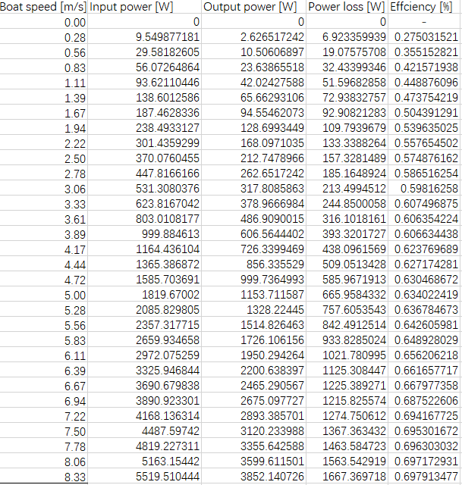

Table 33 Expected results calculations (within margin)

#### Conclusion

When the outputs of the calculation chain do not deviate more than 30% of the measured values, we state that the simulation passes the test.

When the outputs of the calculation chain deviate more than this range, we state that the simulation failed the test.

## V-model design phase (component)

### Component description (motor)

#### Flowchart

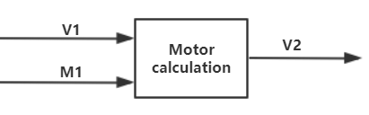

Figure 27 Flowchart motor

**Unique identifiers**

|  |  |
| --- | --- |
| Unique ID | Long Name |
| V1 | Input from user-interface sub-system |
| M1 | Input from gearing component |
| V2 | Output to user-interface sub-system |

Table 34 Unique ID motor

#### Table of limits

|  |  |  |  |  |
| --- | --- | --- | --- | --- |
| Interaction | Symbol | Min. | Max. | Unit |
| -> V1 | | | | |
| *Input from user-interface sub-system* | | | | |
| Boat speed | $$v_{boat}$$ | 0 | 8,5 | m/s |
| Current-Torque coefficient | $$ct$$ | 0 | 1000 | - |
| -> M1 | | | | |
| *Feedback from gearing component* | | | | |
| Rotational speed required | $$n_{Gearing-out}$$ | 0 | 5000 | rpm |
| Torque required | $$T_{Gearing-out}$$ | 0 | 2000 | Nm |
| <- V2 | | | | |
| *Output to user-interface sub-system* | | | | |
| Current required | I | 0 | 250 | A |
| Voltage required | U | 0 | 72 | V |
| Efficiency | η | 0 | 100 | % |
| Power loss | $$P_{Loss}$$ | 0 | 1000 | W |

Table 35 Table of limits motor

### Component test plan (motor)

#### Aim & Hypothesis.

**Aim**

Establish a mathematical model for the relationship between the output and input of the motor

**Hypothesis**

The output power, torque, rotation speed can be calculated by the input velocity and digital twin can be made.

#### Variables

These are the constants and variables that will be used during the test.

|  |  |
| --- | --- |
| Constants simulation | Keep constant at... |
| Ambient temperature | Standard indoor temperature with lower and upper limits (20 ℃ ± 5℃). |
| Battery level computer | Constant power source. |
| All input variables | Real positive numbers & ISO-notation. |

Table 36 Variables motor

**Inputs**

The limits stated are the limits of the real world. If values out of this range are entered, the outputs will be unreliable. Due to the impact of the epidemic, we will use Plan B to simulate the system based on the data sheet.

|  |  |
| --- | --- |
| General input | Value |
| Motor efficiency | 0.84-0.88 |
| Current torque relation coefficient: | 0.18 |

Table 37 General input motor

|  |  |
| --- | --- |
| Inputs for realistic calculation | Value |
| Boat velocity | [0,17] [Km/h] |

Table 38 Inputs for realistic calculation motor

|  |  |
| --- | --- |
| Inputs for theoretical calculation | Value |
| Feedback torque from gear | - |
| Feedback rotation speed from gear | - |
| Gearing power loss | - |

Table 39 Inputs for theoretical calculation motor

**Outputs**

These are the outputs that will be monitored and will be used to see variations or changes in the system. Due to the impact of the epidemic, we will use Plan B to simulate the system based on the data sheet.

|  |  |
| --- | --- |
| Outputs from realistic calculation | Value |
| Motor power output | [0,8800] [w] |
| Motor torque output | [0,40] [Nm] |
| Motor rotation speed ouput | [0,2400] [rpm] |
| Motor power input | [0,8800] [w] |

Table 40 Outputs for realistic calculation motor

|  |  |
| --- | --- |
| Output from theoretical calculation | Value |
| Motor input voltage | - |
| Motor input current | - |
| Motor input power |  |

Table 41 Output from theoretical calculation motor

#### Tools

|  |  |
| --- | --- |
| Testing tools | Demand |
| Computer | Windows 10 compatible |
| Excel | Newest version |
| Keyboard | No limit |
| Mouse | No limit |
| Calculator | Basic calculator |
| Pen & Paper | Basic pen & paper |
| Datasheet | Solar boat relevant data |

Table 42 Tools motor

#### Methods

**Realistic calculation**

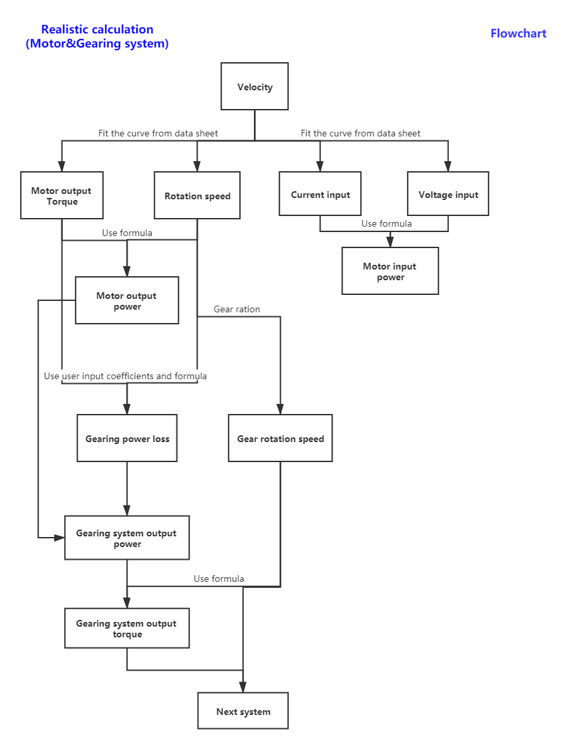

Figure 28 Realistic calculation motor

**Theoretical calculation**

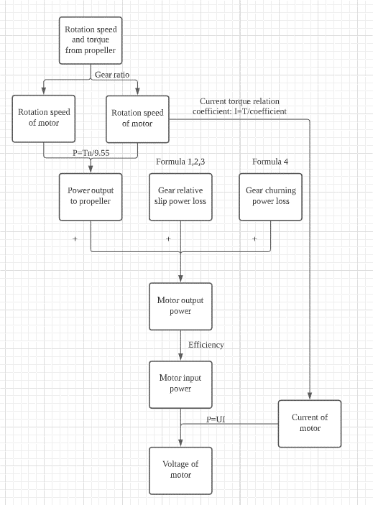

Figure 29 Theoretical calculation motor

When inputting the speed of the ship, compare the motor input and output voltage and current calculated by fitting the curve with the theoretically calculated motor input and output voltage and current. If the error is less than 30%, the digital twin is considered to be successfully established and the fitted curve is used in subsequent calculations.

**Steps**

* Enter target ship velocity in realistic calculation part.
* Obtain the motor output speed, torque, input voltage and current.
* Record these data and enter the theoretical calculation part.
* In the theoretical calculation section, enter the speed and torque fed back to the motor by the gear system at the corresponding ship speed.
* The approximate efficiency of the motor is automatically inferred from the realistic calculated input voltage.
* Get the input voltage and current of the motor.
* Verify the above calculations’ results by paper and pen.
* Determine whether the experiment is successful or not by comparing the results of the data table, theoretical calculation, and theoretical calculation.

#### Expected results

After the user collects data and enters it into the calculation chain, user enters the motor's input voltage, the motor's output power, torque and speed can be calculated.

### Component description (gearing)

#### Flowchart

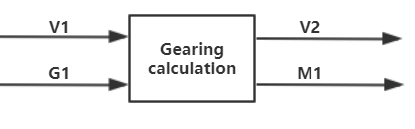

Figure 30 Flowchart gearing

**Unique identifiers**

|  |  |
| --- | --- |
| Unique ID | Long Name |
| V1 | Input from user-interface sub-system |
| G1 | Input from bearing component |
| V2 | Output to user-interface sub-system |
| M1 | Output to motor component |

Table 43 Unique ID gearing

#### Table of limits

|  |  |  |  |  |
| --- | --- | --- | --- | --- |
| Interaction | Symbol | Min. | Max. | Unit |
| -> V1 | | | | |
| *Data from user interface sub-system (input block)* | | | | |
| Gear friction coefficient | $$µ_{gear}$$ | 0,1 | 0,15 | - |
| Gear transmission ratio | $$R_{g}$$ | 0,1 | 10 | # |
| Gear index circle pressure angle | $$α$$ | 15 | 25 | $$°$$ |
| Gear index circle diameter of driving wheel |  | 0 | - | m |
| Gear addendum radius |  | 0 | **-** | m |
| Gear dedendum radius |  | 0 | - | m |
| Gear tooth number |  | 0 | **-** | **-** |
| Gear tooth width ratio | $$b$$ | 0 | - | # |
| Gear modulus | $$m$$ | 0 | - | - |
| Gear immersion depth ratio | $$h$$ | 0 | - | # |
| Gear lubricant viscosity | $$μ$$ | 0 | **-** | mm^2/s |
| Gear lubricant density | $$ρ$$ | 0 | - | $${kg}/{m^{3}}$$ |
| -> G1 | | | | |
| *Data from bearing component* | | | | |
| Rotational speed required | $$n_{Bearing-out}$$ | 0 | 2300 | rpm |
| Torque required | $$T_{Bearing-out}$$ | 0 | 3500 | Nm |
| <- V2 | | | | |
| *Data to user interface sub-system (output block)* | | | | |
| Gear power loss | $$P_{Gear-loss}$$ | 0 | 1000 | W |
| <- M1 | | | | |
| *Data to motor component* | | | | |
| Rotational speed required | $$n_{Gearing-out}$$ | 0 | 5000 | rpm |
| Torque required | $$T_{Gearing-out}$$ | 0 | 2000 | Nm |

Table 44 Table of limits gearing

### Component test plan (gearing)

#### Aim & Hypothesis

**Aim**

The aim of this test is to establish a mathematical model of gear energy loss.

**Hypothesis**

Power, speed and torque after passing through the gear can be calculated by the input value.

#### Variables

These are the constants and variables that will be used during the test.

|  |  |
| --- | --- |
| Constants simulation | Keep constant at... |
| Ambient temperature | Standard indoor temperature with lower and upper limits (20 ℃ ± 5℃). |
| Battery level computer | Constant power source. |
| All input variables | Real positive numbers & ISO-notation. |

Table 45 Variables gearing

**Inputs**

The limits stated are the limits of the real world. If values out of this range are entered, the outputs will be unreliable.

|  |  |
| --- | --- |
| General input | Value |
| Gear friction coefficient(a) | 0.2 |
| Gear transmission ratio | 3 |
| Gear index circle pressure angle(l) | 30 |
| Gear index circle diameter of driving wheel(d) | 0.3 |
| Gear addendum radius(e) | 0.32 |
| Gear dedendum radius(f) | 0.28 |
| Gear tooth number(z) | 15 |
| Gear tooth width ratio(b) | 0.2 |
| Gear modulus(m) | 2 |
| Gear immersion depth ratio(h) | 0.4 |
| Gear lubricant viscosity (u) | 2 |
| Gear lubricant density(p) | 4 |

Table 46 General input gearing

|  |  |
| --- | --- |
| Inputs for realistic calculation | Value |
| Motor power output | [0,8800] [w] |
| Motor torque output | [0,40] [Nm] |
| Motor rotation speed ouput | [0,2400] [rpm] |

Table 47 Inputs for realistic calculation gearing

|  |  |
| --- | --- |
| Inputs for theoretical calculation | Value |
| Feedback rotation speed from propeller | - |
| Feedback torque from propeller | - |

Table 48 Inputs for theoretical calculation gearing

**Outputs**

These are the outputs that will be monitored and will be used to see variations or changes in the system.

|  |  |
| --- | --- |
| Outputs from realistic calculation | Value |
| Gearing power output | [0,8800] [w] |
| Gearing torque output | [0,40] [Nm] |
| Gearing rotation speed ouput | [0,2400] [rpm] |

|  |  |
| --- | --- |
| Outputs from theoretical calculation | Value |
| Feedback rotation speed to motor | - |
| Feedback torque to motor | - |
| Gearing power loss | - |

Table 49 Outputs gearing

#### Tools

|  |  |
| --- | --- |
| Testing tools | Demand |
| Computer | Windows 10 compatible |
| Excel | Newest version |
| Keyboard | No limit |
| Mouse | No limit |
| Calculator | Basic calculator |
| Pen & Paper | Basic pen & paper |
| Mathematical model | Consists of formulas |

Table 50 Tools gearing

#### Methods

**Realistic calculations**



Table 51 Realistic calculation gearing

**Theoretical calculation**



Table 52 Theoretical calculation gearing

When inputting the speed of the ship, compare the motor input and output voltage and current calculated by fitting the curve with the theoretically calculated motor input and output voltage and current. If the error is less than 30%, the digital twin is considered to be successfully established and the fitted curve is used in subsequent calculations. Since the process output value of the gear system is difficult to compare, the output value of the motor system is used as the comparison standard.

**Steps**

* Get the input torque and speed from the motor part.
* Calculate energy loss and rotation speed.
* Calculate output torque from energy loss and speed.
* Record the energy loss and the output speed and torque of the gear system.
* In the theoretical calculation part, input the torque and speed fed back from the propeller to the gear.
* Calculate the speed and speed of the gear feedback to the motor.
* Verify the above calculations’ results by paper and pen.
* The success of the verification of the gear system determines the success or failure of the verification of the motor system. Since the gear system and the motor system are closely connected, the verification of the gear system and the motor system will be combined.

#### Expect result

When power, speed, and torque are transferred from the motor component system to the gear component system, the output power, speed, and torque of the gear system can be calculated according to the set parameters. The gear calculation system can use the data to correctly calculate the result.

#### Conclusion

If the outputs have the same values as their calculated counterparts, the test is considered as passed. If not, the test is considered as failed.

#### Appendix

The energy loss on the gear consists of the meshing between the gears and the gear churning loss. In the gear component, the loss of these two parts will be calculated.

**Gear friction power loss**

$$P_{VZP}=F_{R}×V_{rel}$$

$P_{VZP}$ = load gear losses (kW).

$F_{R}$ =friction force (kN).

$V_{rel}$ =relative velocity (m/s).

**Friction force**

$$F_{R}=F_{n}×μ_{M}$$

$F_{n}$ =Normal force of tooth surface[N].

$μ_{M}$ =Friction coefficient.

$$F_{n}=\frac{F_{t}}{cosα}$$

$$F_{t}=\frac{2T}{d}$$

$F_{t}$ =Gear circumferential force [N].

$α$ =Index circle pressure angle, standard gear is.

T=Torque [N*m].

d=Index circle diameter of driving wheel [m].

**Relative velocity**

The sliding speed is the relative speed of the common contact point between the paired gear teeth in the transverse plane. (Gear Rolling & Sliding velocity) The sliding speed can be approximated as

=Addendum radius[m].

=Deddendum radius[m].

= Angular velocity[rpm].

=Index circle pressure angle, standard gear is.

**Gear churning loss**

Because of lubricate, the gear will face resistance when it is rotating, resulting in energy loss.

=Modulus.

=Number of teeth.

=Lubricant density[].

d=Index circle diameter of driving wheel [m].

$ω$ =Rotation speed[rpm].

$g$ =9.8 $[N/{m^{2}}]$.

$μ$ = Lubricant viscosity.

$\frac{h}{d}$ = Gear immersion depth ratio [0.2 $\sim$ 1].

$\frac{b}{R}$ = Tooth width ratio $[0.2\sim 1]$.

**Gear type**



Figure 31 Gear type



Figure 32 Data gearing

### Component description (bearing)

#### Flowchart

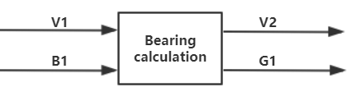

Figure 33 Flowchart bearing

|  |  |
| --- | --- |
| Unique ID | Long Name |
| V1 | Input from user-interface sub-system |
| B1 | Input from propellor component |
| V2 | Output to user-interface sub-system |
| G1 | Output to gearing component |

Table 53 Unique ID bearing

#### Table of limits

|  |  |  |  |  |
| --- | --- | --- | --- | --- |
| Interaction | Symbol | Min. | Max. | Unit |
| -> V1 | | | | |
| *Input from user-interface sub-system* | | | | |
| Bearing friction coefficient | $$µ_{bearing}$$ | $$1,5*{10}^{-3}$$ | $$5*{10}^{-3}$$ | - |
| Bearing seal coefficient | $$µ_{seal}$$ | $$1,5*{10}^{-3}$$ | $$5*{10}^{-3}$$ | - |
| Bearing load | $$F$$ | 0 | 1000 | N |
| Bearing shaft radius | $$r_{shaft}$$ | 0 | 0,05 | m |
| -> B1 | | | | |
| *Input from propellor component* | | | | |
| Rotational speed required | $$n_{Prop-out}$$ | 0 | 2300 | rpm |
| Torque required | $$T_{prop-out}$$ | 0 | 3500 | Nm |
| <- V2 | | | | |
| *Output to user-interface sub-system* | | | | |
| Power loss | $$P_{Bearing-loss}$$ | 0 | 100 | W |
| <- G1 | | | | |
| *Output to gearing component* | | | | |
| Rotational speed required | $$n_{Bearing-out}$$ | 0 | 2300 | rpm |
| Torque required | $$T_{Bearing-out}$$ | 0 | 3500 | Nm |

Table 54 Table of limits bearing

|  |  |
| --- | --- |
| Bearing Type (FRICTION & FREQUENCY FACTORS, sd) | Friction coefficient µ |
| Deep Groove Ball Bearing | 0,0015 |
| Angular Contact Bearing | 0,0020 |
| Cylindrical Roller Bearing, Cage | 0,0010 |
| Cylindrical Roller Bearing, Full Comp. | 0,0020 |
| Tapered Roller Bearing | 0,0020 |
| Spherical Roller Bearing | 0,0020 |
| Ball Thrust Bearing | 0,0015 |
| Cylindrical Roller Thrust Bearing | 0,0050 |
| Tapered Roller Thrust Brg. Cage | 0,0020 |
| Tapered Roller Thrust Brg. Full Comp | 0,0050 |

Table 55 Friction coefficients bearing

### Component test plan (bearing)

#### Aim & Hypothesis

**Aim**

The aim of this test is to verify the simulated mathematical model of the bearing calculations.

**Hypothesis**

The bearing simulation has the same desired output values, compared to the calculations.

#### Variables

These are the constants and variables that will be used during the test.

|  |  |
| --- | --- |
| Constants simulation | Keep constant at... |
| Battery level computer | Constant power source. |
| All input variables | Real positive numbers & ISO-notation. |

Table 56 Variables bearing

**Inputs**

The limits stated are the limits of the real world. If values out of this range are entered, the outputs will be unreliable.

|  |  |
| --- | --- |
| Inputs | Value |
| Rotational speed [rpm] | 0 - 2200 |
| Bearing friction coefficient | 0,0015 – 0,0050 |
| Seal friction coefficient | 0,0015 – 0,0050 |
| Load [N] | 0 – 1000 |
| Radius shaft [m] | 0 – 0,2 |

Table 57 Inputs bearing

**Outputs**

These are the outputs that will be monitored and will be used to see variations or changes in the system.

|  |  |
| --- | --- |
| Outputs | Value |
| Bearing power output [W] | 0 - 8400 |
| Bearing torque output [Nm] | 0 - 3500 |
| Power loss [W] | 0 – 8400 |
| Power loss [%] | 0 – 100 |

Table 58 Outputs bearing

#### Tools

|  |  |
| --- | --- |
| Testing tools | Demand |
| Computer | Windows 10 compatible |
| Excel | Newest version |
| Keyboard | No limit |
| Mouse | No limit |
| Calculator | Basic calculator |
| Pen & Paper | Basic pen & paper |

Table 59 Tools bearing

#### Methods

The simulation will be compared to the actual calculations to see if they are the same.

**Steps**

1. Put the different values from 2.1 in the simulation
2. Note the outputs
3. Calculate the outputs based on the mathematical model (7.Appendix) using pen, paper and calculator
4. Note the answers.
5. Compare the two answers

#### Expected results

The expected outputs are according to the mathematical models and between the range stated in the table 2.2

#### Conclusion

If the outputs have the same values as their calculated counterparts, the test is considered as passed.

If not, the test is considered as failed.

#### Appendix

**Friction force**

$$F_{friction}=F_{load}*µ$$

$F_{friction}$ =loss due to friction [N]

$F_{load}$ =load from axis on bearing [N]

µ=friction coefficient

**Powerloss due to friction**

$$P_{out}=P_{in}-\left(\left(F_{friction}*r_{shaft}\right)*ω\right)$$

$P_{out}$ = output power [W].

= input power [W].

$F_{friction}$ =loss due to friction [N]

$r_{shaft}$ =radius driving shaft [m]

ω=angular velocity [rad/s]

$$T=\frac{60}{2π}×\frac{P}{n}$$

T=torque [Nm].

P=power [W].

n=rotation speed [rpm].

### Component description (propeller)

#### Flowchart

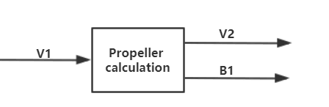

Figure 34 Flowchart propellor

|  |  |
| --- | --- |
| Unique ID | Long Name |
| V1 | Input from user-interface sub-system |
| V2 | Output to user-interface sub-system |
| B1 | Output to bearing component |

Table 60 Unique ID propellor

#### Table of limits

|  |  |  |  |  |
| --- | --- | --- | --- | --- |
| Interaction | Symbol | Min. | Max. | Unit |
| -> V1 | | | | |
| *Input from user-interface sub-system* | | | | |
| Boat speed | Vb | 0 | 8,5 | m/s |
| Propeller diameter | $$d_{prop}$$ | 0,1 | 0,5 | m |
| Liquid density | $$ρ$$ | 980 | 1000 | kg/m3 |
| Thrust deduction coefficient | t | 0 | 1 | - |
| Wake fraction coefficient | w | 0 | 1 | - |
| <- V2 | | | | |
| *Output to user-interface sub-system* | | | | |
| Thrust | $$F_{T}$$ | 0 | 500 | N |
| Rotational speed propeller | $$n_{P}$$ | 0 | 2300 | rpm |
| Power output | $$P_{output}$$ | 0 | 5000 | W |
| Power loss | $$P_{loss}$$ | 0 | 1000 | W |
| <- B1 | | | | |
| *Feedback to bearing component* | | | | |
| Rotational speed required | $$n_{Prop-out}$$ | 0 | 2300 | rpm |
| Torque required | $$T_{Prop-out}$$ | 0 | 3500 | Nm |

Table 61 Table of limits propellor

### Component test plan (propeller)

#### Aim & Hypothesis

**Aim**

The aim of this test is to verify the simulated mathematical model of the propellor calculations.

**Hypothesis**

The propellor simulation has the same output as the calculations.

#### Variables

These are the constants and variables that will be used during the test.

|  |  |
| --- | --- |
| Constants simulation | Keep constant at... |
| Battery level computer | Constant power source. |
| All input variables | Real positive numbers & ISO-notation. |

Table 62 Variables propellor

**Inputs**

The limits stated are the limits of the real world. If values out of this range are entered, the outputs will be unreliable.

|  |  |
| --- | --- |
| Inputs | Value |
| Boat speed [m/s] | 0 – 8,5 |
| Propellor diameter [m] | 0,1 - 0,5 |
| Liquid density [kg/m3] | 980 - 1000 |
| Thrust deduction coefficient | 0 - 1 |
| Wake fraction coefficient | 0 - 1 |
| Propellor properties: Rtotal at Vb | 0 - 500 |
| Propellor properties: η at Vb | 0 – 100 |
| Propellor properties: Kt at Vb | 0 – 1 |
| Propellor properties: Kq at Vb | 0 – 1 |

Table 63 Inputs propellor

**Outputs**

These are the outputs that will be monitored and will be used to see variations or changes in the system.

|  |  |
| --- | --- |
| Outputs | Value |
| Thrust [N] | 0 - 500 |
| Rotational speed propeller [rpm] | 0 - 2200 |
| Torque required [Nm] | 0 - 3500 |
| Power output [W] | 0 - 8400 |
| Power loss [W] | 0 - 8400 |

Table 64 Outputs propellor

#### Tools

|  |  |
| --- | --- |
| Testing tools | Demand |
| Computer | Windows 10 compatible |
| Excel | Newest version |
| Keyboard | No limit |
| Mouse | No limit |
| Calculator | Basic calculator |
| Pen & Paper | Basic pen & paper |
| Mathematical model | Using correct formulas |

Table 65 Tools propellor

#### Method

The simulation will be compared to the actual calculations to see if they are the same.

**Steps**

1. Put the different values from 2.1 in the simulation
2. Note the outputs
3. Calculate the outputs based on the mathematical model (7.Appendix) using pen, paper and calculator
4. Note the answers.
5. Compare the two answers.

#### Expected results

The expected outputs are according to the mathematical models and between the range stated in the table 2.2.

#### Conclusion

If the outputs have the same values as their calculated counterparts, the test is considered as passed.  
If not, the test is considered as failed.

#### Explanation

The experiment of propeller alone in uniform water flow is called open water experiment. The following formulas and coefficients can be applied in these circumstances.

#### Formulas

**Force equilibrium (speed is constant)**

$$Ft=Fr$$

Ft = thrust (N).

Fr = resistance (N).

**Resistance force**

$$Rtotal=\left(1-t\right)*Fr$$

Rtotal = total boat resistance (N)

T = thrust deduction factor

Fr = resistance (N).

**Interpolation formula**

(x, y) = coordinates of interpolation value

**Thrust coefficient**

Ft = thrust (N).

= liquid density ().

n = rotating speed (rev/s).

d = diameter (m).

= thrust coefficient.

**Torque coefficient**

*QE = QR – QI*

= torque difference(Nm).

= torque required (Nm).

= torque input (Nm).

= liquid density ().

n = rotating speed (rev/s).

d = diameter (m).

= torque coefficient.

**Power output**

P = output power (W)

F = force (N)

v = velocity(m/s).

**Power input**

P = input power (W)

T = torque (Nm)

ω = radial velocity (rad/s).

**Stream velocity**

Va = inflow stream velocity (m/s)

Vb = boat speed (m/s)

W = wake fraction

**Propellor efficiency**

Ft = thrust (N)

Va = inflow stream velocity (m/s)

N = radial velocity (rad/s)

= torque required (Nm).

**Propulsive efficiency**

Rtotal = total boat resistance (N)

Vb = boat speed (m/s)

N = radial velocity (rad/s)

= torque required (Nm).

**Required rpm**

$$\left.\begin{aligned}P=T*n*\frac{2π}{60} \\ T=Q_{R}=ρ×{(n/60)}^{2}×d^{5}×K_{Q}\end{aligned}\right\}n={\left(\frac{P*{60}^{3}}{ρ*d^{5}*K_{Q}*2π}\right)}^{\frac{1}{3}}$$

P = input power (W)

n = radial velocity (rpm)

T = $Q_{R}$ = torque required (Nm).

$ρ$ = liquid density (${kg}/{m^{3}}$).

d = diameter (m).

$K_{Q}$ = torque coefficient.

### Component description (input block)

#### Flowchart

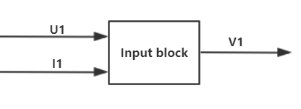

Figure 35 Flowchart input block

|  |  |
| --- | --- |
| Unique ID | Long Name |
| U1 | User input |
| I1 | Simulation input state signal |
| V1 | User-interface sub-system output (input block output) |

Table 66 Unique ID input block

#### Table of limits

|  |  |  |  |  |
| --- | --- | --- | --- | --- |
| Interaction | Symbol | Min. | Max. | Unit |
| -> U1 | | | | |
| *Data from normal users* | | | | |
| Limit input | | | | |
| Boat speed | $$v_{boat}$$ | 0 | 8,5 | m/s |
| *Data from administrators* | | | | |
| Properties input (used to set up calculation) | | | | |
| Motor current-torque coefficient | $$ct$$ | 0 | 100 | - |
| Bearing friction coefficient | $$µ_{bearing}$$ | $$1,5*{10}^{-3}$$ | $$5*{10}^{-3}$$ | - |
| Bearing seal coefficient | $$µ_{seal}$$ | $$1,5*{10}^{-3}$$ | $$5*{10}^{-3}$$ | - |
| Bearing load | $$F$$ | 0 | 1000 | N |
| Bearing shaft radius |  | 0 | 0,05 | m |
| Gear friction coefficient |  | 0,1 | 0,15 | - |
| Gear transmission ratio |  | 0,1 | 10 | # |
| Gear index circle pressure angle |  | 15 | 25 |  |
| Gear index circle diameter of driving wheel |  | 0 | - | m |
| Gear addendum radius |  | 0 | **-** | m |
| Gear dedendum radius |  | 0 | - | m |
| Gear tooth number |  | 0 | **-** | **-** |
| Gear tooth width ratio |  | 0 | - | # |
| Gear modulus |  | 0 | - | - |
| Gear immersion depth ratio |  | 0 | - | # |
| Gear lubricant viscosity |  | 0 | **-** | mm^2/s |
| Gear lubricant density |  | 0 | - |  |
| Propellor diameter |  | 0,1 | 0,5 | m |
| Propellor thrust deduction coefficient | $$t$$ | 0 | 1 | - |
| Propellor wake fraction coefficient | $$w$$ | 0 | 1 | - |
| Propellor liquid density (water) | $$ρ$$ | 980 | 1000 | Kg/m^3 |
| -> I1 | | | | |
| Simulation input state signal | - | 0（false） | 1(true) | - |
| <- V1 | | | | |
| *Data to different calculation components* | | | | |
| Limit output | | | | |
| Boat speed | $$v_{boat}$$ | 0 | 8,5 | m/s |
| Properities output (used to set up calculation) to motor calculation | | | | |
| Motor current-torque coefficient | $$ct$$ | 0 | 100 | - |
| Properities output (used to set up calculation) to bearing calculation | | | | |
| Bearing friction coefficient | $$µ_{bearing}$$ | $$1,5*{10}^{-3}$$ | $$5*{10}^{-3}$$ | - |
| Bearing seal coefficient | $$µ_{seal}$$ | $$1,5*{10}^{-3}$$ | $$5*{10}^{-3}$$ | - |
| Bearing load | $$F$$ | 0 | 1000 | N |
| Bearing shaft radius | $$r_{shaft}$$ | 0 | 0,05 | m |
| Properities output (used to set up calculation) to gearing calculation | | | | |
| Gear friction coefficient | $$µ_{gear}$$ | 0,1 | 0,15 | - |
| Gear transmission ratio | $$R_{g}$$ | 0,1 | 10 | # |
| Gear index circle pressure angle | $$α$$ | 15 | 25 | $$°$$ |
| Gear index circle diameter of driving wheel |  | 0 | - | m |
| Gear addendum radius |  | 0 | **-** | m |
| Gear dedendum radius |  | 0 | - | m |
| Gear tooth number |  | 0 | **-** | **-** |
| Gear tooth width ratio | $$b$$ | 0 | - | # |
| Gear modulus | $$m$$ | 0 | - | - |
| Gear immersion depth ratio | $$h$$ | 0 | - | # |
| Gear lubricant viscosity | $$μ$$ | 0 | **-** | mm^2/s |
| Gear lubricant density | $$ρ$$ | 0 | - | $${kg}/{m^{3}}$$ |
| Properities output (used to set up calculation) to propeller calculation | | | | |
| Propellor diameter | $$d_{prop}$$ | 0,1 | 0,5 | m |
| Propellor thrust deduction coefficient | $$t$$ | 0 | 1 | - |
| Propellor wake fraction coefficient | $$w$$ | 0 | 1 | - |
| Propellor liquid density (water) | $$ρ$$ | 980 | 1000 | Kg/m^3 |

Table 67 Table of limits input block

### Component test plan (input block)

#### Aim & Hypothesis

**Aim**

The aim is to verify that the data can be transmitted from the user to the calculation.

**Hypothesis**

The user input is transmitted to the calculation.

#### Variables

These are the constants and variables that will be used during the test.

|  |  |
| --- | --- |
| Constants simulation | Keep constant at... |
| Battery level computer | Constant power source. |
| All input variables | Real positive numbers & ISO-notation. |

Table 68 Variables input block

**Inputs**

The limits stated are the limits of the real world. If values out of this range are entered, the outputs will be unreliable.

|  |  |
| --- | --- |
| Inputs | Value |
| Value 1 (input variables) | 1-10 |
| … | - |
| Value 2 (constant coefficient) | 1-10 |
| … | - |

Table 69 Inputs input block

**Outputs**

These are the outputs that will be monitored and will be used to see variations or changes in the system.

|  |  |
| --- | --- |
| Outputs | Value |
| Output value 1 | 1-100 |
| … | - |

Table 70 Outputs input block

#### Tools

|  |  |
| --- | --- |
| Testing tools | Demand |
| Computer | Windows 10 compatible |
| Excel | Newest version |
| Keyboard | No limit |
| Mouse | No limit |
| Calculator | Basic calculator |
| Pen & Paper | Basic pen & paper |

Table 71 Tools input block

#### Methods

This section consists of actions that need to be performed during the test to conclude a result. The conditions of the constants stated in chapter “2. Variables” have to be met before executing the simulation. To execute the simulation, follow the steps stated in “4.1. Steps”.

This part is a general test method which should be test several times to make sure when input block is connected to all different formulas which will be used in calculation component, the data can be transmitted from input block successfully.

In this general test method part, the formula P =U*I is used to give an example. We set **U (value 1)** as an input variable and **I (value 2)** is a constant which can be seen as a coefficient. **P** is the **output value 1**. According to different formulas, there can be several input variables, coefficients, and outputs.

**Steps**

1. Create a new form in Excel.
2. Take the grid A2 as the input block of **U**. Take the grid B2 as the input block of **I**.
3. Take the grid AC2 as the indicator of calculation result. And add a formula to C2: = B2 * A2.

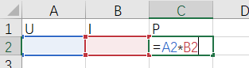

Figure 36 Formula input block

1. Choose a numeric value of **I** and input this value to B2
2. Choose several numeric values of **U** and input values to A1 and record results from C2.
3. Calculate several results according to different values of **U** on paper.
4. Compare the results from paper calculation and C2.
5. Input a non-numeric value to A2 and record the result from C2

#### Expected results.

When numeric values of A2 is input, the values of C2 should be equal to results from paper calculation.

When a non-numeric value of A2 is input, text ‘#VALUE’ (specify text of Excel which means the calculation result is not a numeric value) should be shown in C2.

#### Conclusion

When numeric values of A2 is input, if the values of C2 are not equal to results from paper calculation or text ‘#VALUE’ appears in C2, the test is failed.

When a non-numeric value of A2 is input, a numeric value appears in C2, the test is failed.

If other all conditions which meet the expect results appear, the tests are successful.

### Component description (Output block)

#### Flowchart

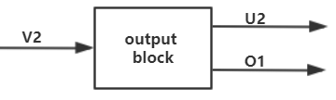

Figure 37 Flowchart output block

|  |  |
| --- | --- |
| Unique ID | Long Name |
| V2 | Calculation sub-system output |
| U2 | Simulation output |
| O1 | Simulation state signal |

Table 72 Unique ID output block

#### Table of limits

|  |  |  |  |  |
| --- | --- | --- | --- | --- |
| Interaction | Symbol | Min. | Max. | Unit |
| -> V2 | | | | |
| *Data from calculation sub-system* | | | | |
| Limit input | | | | |
| Thrust | $$F_{T}$$ | 0 | 500 | N |
| Boat velocity | $$V$$ | 0 | 30 | Km/h |
| Rotational speed propeller | $$n_{P}$$ | 0 | 2300 | rpm |
| Power input | $$P_{input}$$ | 0 | 6000 | W |
| Power output | $$P_{output}$$ | 0 | 4100 | W |
| Power loss | $$P_{loss}$$ | 0 | 810 | W |
| Current required | I | 0 | 250 | A |
| Voltage required | U | 0 | 72 | V |
| Efficiency | $$η$$ | 0 | 100 | % |
| <- U2 | | | | |
| *Data to normal users and administrators* | | | | |
| Limit output | | | | |
| Thrust | $$F_{T}$$ | 0 | 500 | N |
| Boat velocity | $$V$$ | 0 | 30 | Km/h |
| Rotational speed propeller |  | 0 | 2300 | rpm |
| Power input | $$P_{input}$$ | 0 | 6000 | W |
| Power output | $$P_{output}$$ | 0 | 4100 | W |
| Power loss | $$P_{loss}$$ | 0 | 810 | W |
| Current required | I | 0 | 250 | A |
| Voltage required | U | 0 | 72 | V |
| Efficiency | $$η$$ | 0 | 100 | % |
| <- O1 | | | | |
| Simulation state signal | - | 0 (false) | 1 (true) | - |

Table 73 Table of limits output block

### Components test plan (Output block)

#### Aim & Hypothesis

**Aim**

The aim is to verify the outputs from the calculations components can be shown correctly by the output block.

**Hypothesis**

The results shown by the output block are same as calculation results.

#### Variables

These are the constants and variables that will be used during the test.

|  |  |
| --- | --- |
| Constants simulation | Keep constant at... |
| Battery level computer | Constant power source. |
| All input variables | Real positive numbers & ISO-notation. |

Table 74 Variables output block

**Inputs**

The limits stated are the limits of the real world. If values out of this range are entered, the outputs will be unreliable.

|  |  |
| --- | --- |
| Inputs | Value |
| Value 1 (input power) | Random positive numeric numbers |
| Value 2 (efficiency) | Random positive numeric numbers between 0 and 1 |

Table 75 Inputs output block

**Outputs**

These are the outputs that will be monitored and will be used to see variations or changes in the system.

|  |  |
| --- | --- |
| Outputs | Value |
| Output value 1 (output power) | Random positive numeric numbers |
| Output value 2 (power loss) |

Table 76 Outputs output block

#### Tools

|  |  |
| --- | --- |
| Testing tools | Demand |
| Computer | Windows 10 compatible |
| Excel | Newest version |
| Keyboard | No limit |
| Mouse | No limit |
| Calculator | Basic calculator |
| Pen & Paper | Basic pen & paper |

Table 77 Tools output block

#### Methods

This section consists of actions that need to be performed during the test to conclude a result. The conditions of the constants stated in chapter “2. Variables” have to be met before executing the simulation. To execute the simulation, follow the steps stated in “4.1. Steps”.

In this test, the output value will be shown with a pie chart which consists of output power and power loss.

**Steps**

1. Create a new form in Excel.
2. Take the grid A2 as the input block of **value 1 (input power)**. Take the grid B2 as the input **value 2 (efficiency).**
3. Take the grid C2 as the indicator of **output value 1 (output power)**. Take the grid D2 as the indicator of **output value 2 (power loss)**. And add a formula to C2: = A2 * B2. Add a formula to D2: =A2 * (1 – B2).

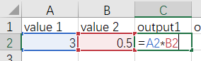

Figure 38 Formula 1 output block

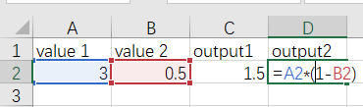

Figure 39 Formula 2 output block

1. Choose a numeric value of **value 1 (input power)** and input this value to A2
2. Choose a numeric value between 0 and 1 of **value 2 (efficiency)** and input this value to B2
3. Calculate **output value 1 (output power)** and **output value 2 (power loss)** on paper.
4. Use the data from C2 and D2 to create a pie chart.

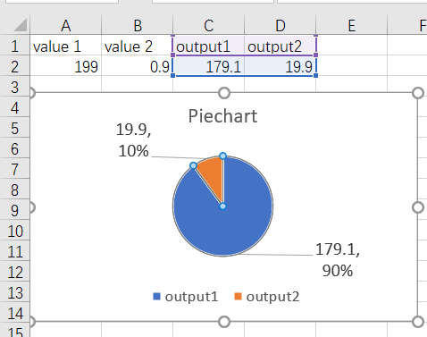

Figure 40 Piechart output block]

1. Compare the results from paper calculation and C2, D2 and pie chart.

#### Expected results.

The values of C2 and D2 are equal to results of paper calculation.

The ratio between C2 and D2 is equal to the value of efficiency.

The ratio of areas of **output value 1 (output power)** and **output value 2 (power loss)** in the pie chart is equal to the value of effiency.

The values of **output value 1 (output power)** and **output value 2 (power loss)** shown in pie chart are equal to values from C2 and D2.

#### Conclusion

If every condition in ‘5. Expect result’ is met, the test is successful.

If one of the conditions in’5. Expect result’ can’t be met, the test is failed.

### Component description (Warning and prompts)

#### Flowchart

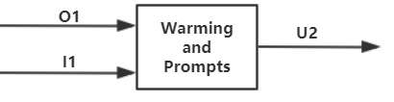

Figure 41 Flowcharts prompts

|  |  |
| --- | --- |
| Unique ID | Long Name |
| U2 | Simulation output |
| I1 | Simulation input state signal |
| O1 | Simulation state signal |

Table 78 Unique ID prompts

#### Table of limits

|  |  |  |  |  |
| --- | --- | --- | --- | --- |
| Interaction | Symbol | Min. | Max. | Unit |
| -> U2 | | | | |
| *Data to normal users and administrators* | | | | |
| Limit output | | | | |
| Prompts for successful simulation | - | Successful simulation | | - |
| Warnings for unsuccessful simulation | - | Simulation failed | | - |
| Prompts for how to optimize unsuccessful simulation | *-* | Input error. Insert numeric values | | - |
| -> I1 | | | | |
| Simulation input state signal | - | 0 | 1 | - |
| -> O1 | | | | |
| Simulation state signal | - | 0 | 1 | - |

Table 79 Table of limits prompts

### Component test plan (Warning and prompts)

#### Aim & Hypothesis

**Aim**

Verify the warnings and prompts component can clearly inform users the state of the simulation.

**Hypothesis**

Warnings and prompts appear on the right time when simulations are failed or successful.

#### Variables

These are the constants and variables that will be used during the test.

|  |  |
| --- | --- |
| Constants simulation | Keep constant at... |
| Battery level computer | Constant power source. |
| All input variables | Real positive numbers & ISO-notation. |

Table 80 Variables prompts

**Inputs**

The limits stated are the limits of the real world. If values out of this range are entered, the outputs will be unreliable.

|  |  |
| --- | --- |
| Inputs | Value |
| Input value [U] | Random numbers, letters, and signals |
| Simulation input state signal | True or False |

Table 81 Inputs prompts

**Outputs**

These are the outputs that will be monitored and will be used to see variations or changes in the system.

|  |  |
| --- | --- |
| Outputs | Value |
| Prompts for successful simulation | Successful simulation |
| Warnings for unsuccessful simulation | Simulation failed |
| Prompts for how to optimize unsuccessful simulation | Input error. Please insert numeric values. |

Table 82 Outputs prompts

#### Tools

|  |  |
| --- | --- |
| Testing tools | Demand |
| Computer | Windows 10 compatible |
| Excel | Newest version |
| Keyboard | No limit |
| Mouse | No limit |
| Calculator | Basic calculator |
| Pen & Paper | Basic pen & paper |

Table 83 Tools prompts

#### Methods

This section consists of actions that need to be performed during the test to conclude a result. The conditions of the constants stated in chapter “2. Variables” have to be met before executing the simulation. To execute the simulation, follow the steps stated in “4.1. Steps”.

In this test, a simulation in Excel with the same structure as the following graph is needed.



Figure 42 Structure prompts

Input value [U] is the value we need to change. Coefficient [I] is a constant which will be set before test. Output value [P] is equal to ‘input value * coefficient [I]’. The simulation input state signal shows the state of input value [U]. If input value [U] is a numeric number, simulation input state signal is True, otherwise it will be False. The simulation state signal shows the state of output value [P]. If output value [p] is a numeric number, simulation state signal is True, otherwise it will be False.

**Steps**

1. Create a new form in Excel.
2. Take the grid A2 as the input block of **Input value [U]**. Take the grid B2 as the indicator of **simulation input state signal.**
3. Take the grid C2 as the indicator of **coefficient [I]**. Take the grid E2 as the indicator of **output value [p]**. Take the grid F2 as the indicator of **simulation state signal**. And add a formula to E3: = A2 * C2.
4. Add the function ‘Isnumber()’ to grid B2 and monitor the value of A2. Add the function ‘Isnumber()’ to grid F2 and monitor the value of e2.
5. Input all the codes in following graph in ‘Developer >> Visual Basic >> Sheet1 (Sheet1)’.

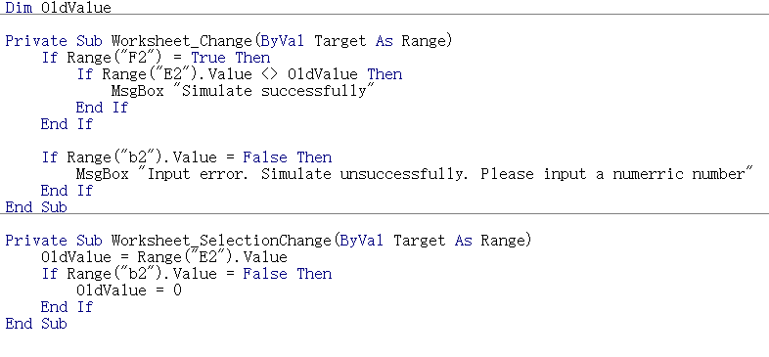

Figure 43 Code prompts

1. Set the value of coefficient with a random numeric number.
2. Choose a numeric value for **input value [U]** and input this value to A2
3. Record the results from B2 and F2. Also record the messages from the message boxes.
4. Choose a non-numeric value for **input value [U]** and input this value to A2
5. Record the results from B2 and F2. Also record the messages from the message boxes.

#### Expected results.

When a numeric value is input in A2. The values of B2 and F2 are both True and message box should be same as the following picture:

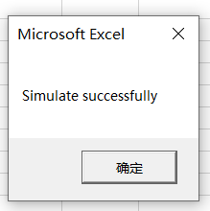

Figure 44 Successful simulation

When a non-numeric value is input in A2. The values of B2 and F2 are both False and message box should be same as the following picture:

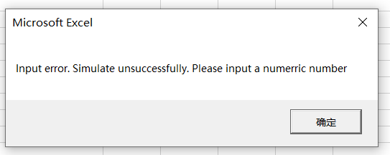

Figure 45 Unsuccessful simulation

#### Conclusion

When a numeric value is input in A2, there is no prompts of successful simulation, and when a non-numeric value is input in A2, there is no warning, the test are failed.

Otherwise, the tests are successful.

## V-model integration phase (component)

### Component integration (motor)

#### Build up

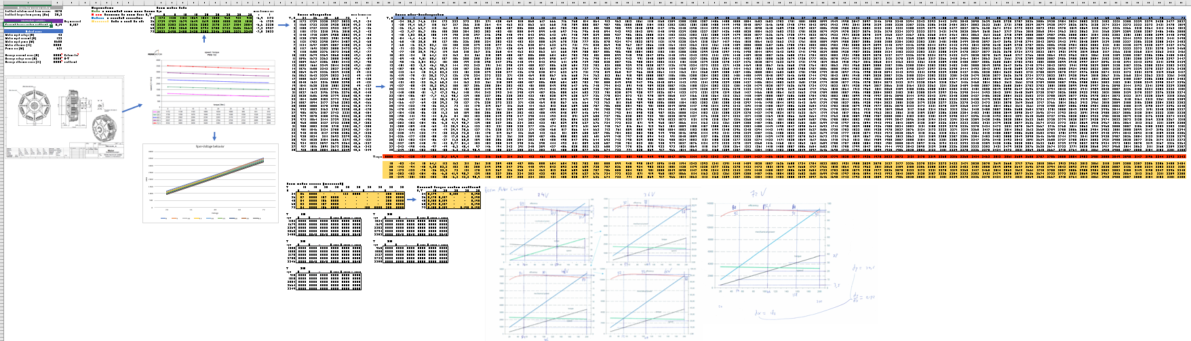

Figure 46 Buildup motor

#### Log test data

**Performed steps**

1. Open up simulation.
2. Insert variables.
3. Calculate with the same variables.
4. Compare results.

**Results**

This is the result with the simulation:

In realistic calculation when the input boat velocity is 10km/h.

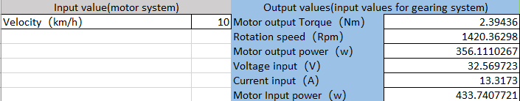

Figure 47 Realistic result motor

In theoretical calculation:

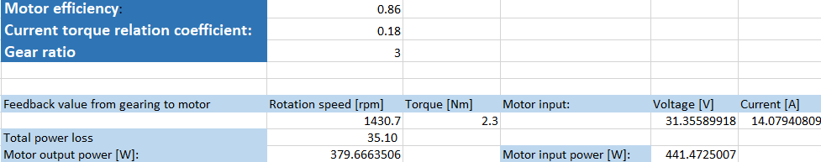

Figure 48 Theoretical result motor

This is the result of the calculations:

$$P_{in}=\frac{P_{out}}{η}$$

$$T∝I$$

$$P=UI=\frac{TN}{9.55}$$

**Conclusion**

In conclusion, the outputs from the realistic calculation match the outputs from the theoretical calculation and data sheet. Therefore, the hypothesis:

*“the motor simulation has the same output as the calculations*”

is correct and the simulation works as intended.

### Component integration (gearing)

#### Build up

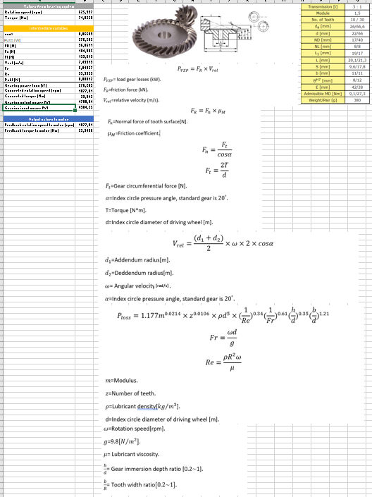

Figure 49 Buildup gearing

#### Log test data

**Performed steps**

1. Open up simulation.
2. Insert variables.
3. Calculate with the same variables.
4. Compare results.

**Results**

This is the result with the simulation:

In realistic calculation when the input boat velocity is 10km/h.

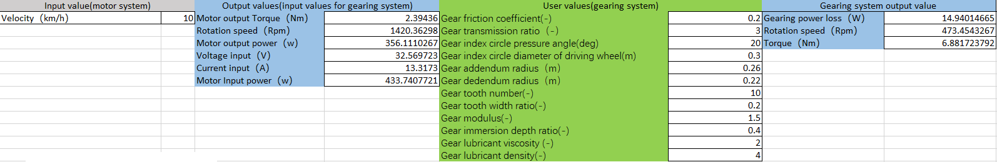

Figure 50 Realistic result gearing

In theoretical calculation:

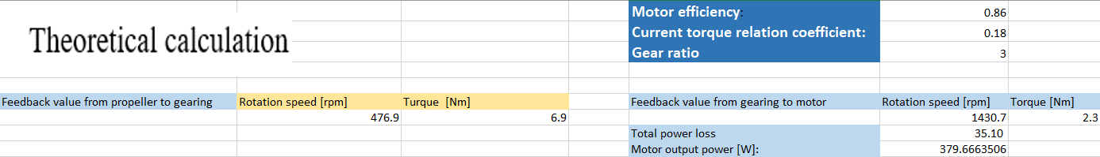

Figure 51 Theoratical result gearing

This is the result of the calculations:

$$P_{loss}=P_{VZP}+P_{churning}=F_{R}*V_{rel}+1.177m^{0.0214}×z^{0.0106}×ρd^{5}×{(\frac{1}{Re})}^{0.34}{(\frac{1}{Fr})}^{0.61}{(\frac{h}{d})}^{0.35}{(\frac{b}{d})}^{1.21}$$

= $\frac{\frac{2T}{d}}{cosα}×μ×\frac{\left(d_{1}+d_{2}\right)}{2}×ω×2×cosα+1.177m^{0.0214}×z^{0.0106}×ρd^{5}×{\left(\frac{1}{Re}\right)}^{0.34}{\left(\frac{1}{Fr}\right)}^{0.61}{\left(\frac{h}{d}\right)}^{0.35}{\left(\frac{b}{d}\right)}^{1.21}$

$$=14.94(w)$$

$$N=\frac{N_{motor}}{r}=473.45(rpm)$$

$$T=9.55×\frac{P_{in}-P_{loss}}{N}=6.88(Nm)$$

**Conclusion**

In conclusion, the outputs from the realistic calculation match the outputs from the theoretical calculation and data sheet. Therefore, the hypothesis:

*“the gearing simulation has the same output as the calculations”*

is correct and the simulation works as intended.

### Component integration (bearing)

#### Build up

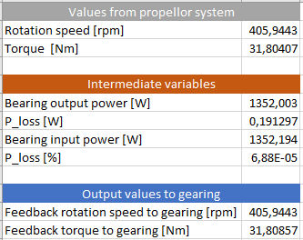

Figure 52 Buildup bearing

#### Log test data

**Performed steps**

1. Open up simulation.
2. Insert variables.
3. Calculate with the same variables.
4. Compare results.

**Results**

This is the result with the simulation:

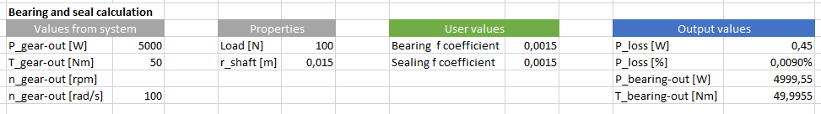

Figure 53 Result bearing

This is the result of the calculations:

$$F_{friction}=F_{load}*µ=100*\left(0,0015+0,0015\right)=0,3 [N]$$

$$P_{out}=P_{in}-\left(\left(F_{friction}*r_{shaft}\right)*ω\right)=5000-\left(\left(0,3*0,015\right)*100\right)=4999,55 \left[W\right]$$

**Conclusion**

In conclusion, the outputs from the simulation match the outputs from the calculations. Therefore, the hypothesis:

*“The bearing simulation has the same desired output values, compared to the calculations.”*

is correct and the simulation works as intended.

### Component integration (propellor)

#### Build up

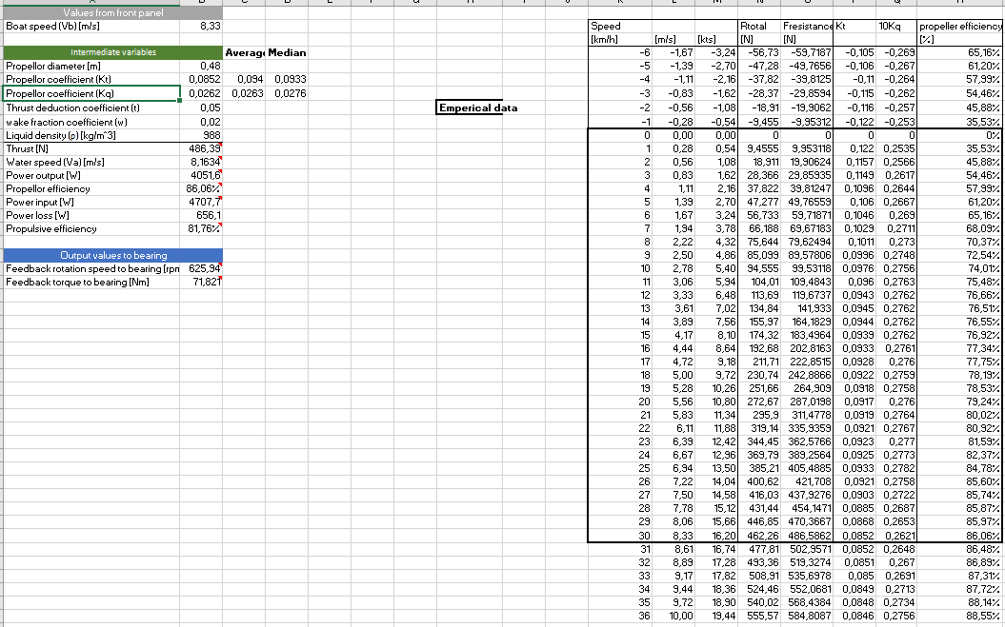

Figure 54 Buildup propellor

#### Log test data

**Performed steps**

1. Open up simulation.
2. Insert variables.
3. Calculate with the same variables.
4. Compare results.

**Results**

This is the result with the simulation:

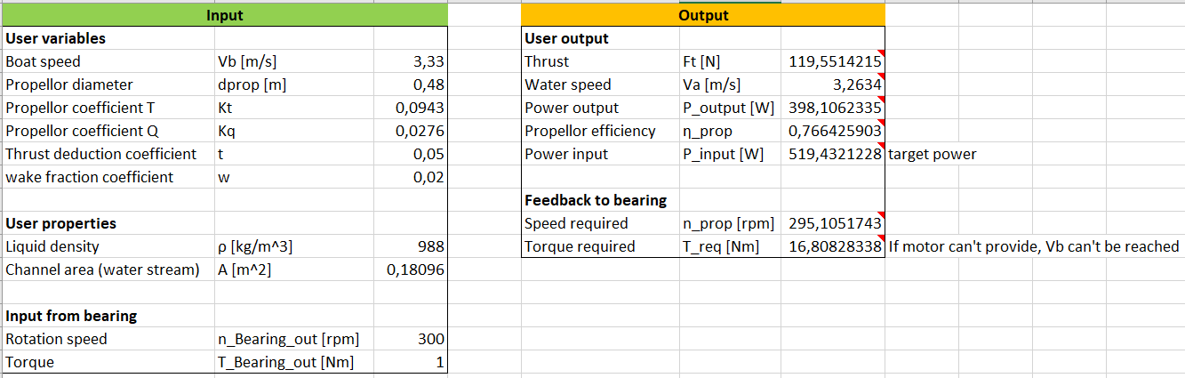

Figure 55 Result propellor

This is the result of the calculations:

$$F_{t}=ρ*n^{2}\left[rps\right]*d^{4}*K_{T}=988*{\frac{295,63}{60}}^{2}*{0,48}^{4}*0,0943=119,6[N]$$

$$P=F*v=119,6*3,33=398,3$$

**Conclusion**

In conclusion, the outputs from the simulation match the outputs from the calculations. Therefore, the hypothesis:

*“the propellor simulation has the same output as the calculations”*

is correct and the simulation works as intended.

### Component integration (warnings and prompts)

#### Log test data

**Performed steps**

1. Open up simulation.
2. Insert variables.
3. Compare results with expected results from “test plan”.

**Results**

This is the result with the simulation when a numeric value is inserted:



Figure 56 Result warning numeric

This is the result with the simulation when a non-numeric value is inserted:



Figure 57 Result warning non-numeric

**Conclusion**

In conclusion, the outputs from the simulation match the outputs from the calculations. Therefore, the hypothesis:

*“Warnings and prompts appear on the right time when simulations are failed or successful.”*

is correct and the simulation works as intended.

### Component integration (input block)

#### Log test data

**Performed steps**

1. Open up simulation.
2. Insert variables.
3. Compare results with expected results from “test plan”.

**Results**

This is the formula. Block A1 is an input block. Block B1 is the output block. For the formula “=”, they are both the same. Therefore the input and output blocks both work.



Figure 58 Result input block



Figure 59 Result 2 input block

**Conclusion**

In conclusion, the outputs from the simulation match the outputs from the calculations. Therefore, the hypothesis:

*“The user input is transmitted to the calculation.”*

is correct and the simulation works as intended.

### Component integration (output block)

#### Log test data

**Performed steps**

1. Open up simulation.
2. Insert variables.
3. Compare results with expected results from “test plan”.

**Results**

This is the formula. Block A1 is an input block. Block B1 is the output block. For the formula “=”, they are both the same. Therefore the input and output blocks both work.



Figure 60 Result output block



Figure 61 Result 2 output block

**Conclusion**

In conclusion, the outputs from the simulation match the outputs from the calculations. Therefore, the hypothesis:

*“The results shown by the output block are same as calculation results”*

is correct and the simulation works as intended.

## V-model integration phase (subsystem)

### Subsystem integration (user interface)

#### Build up



Figure 62 Buildup user interface

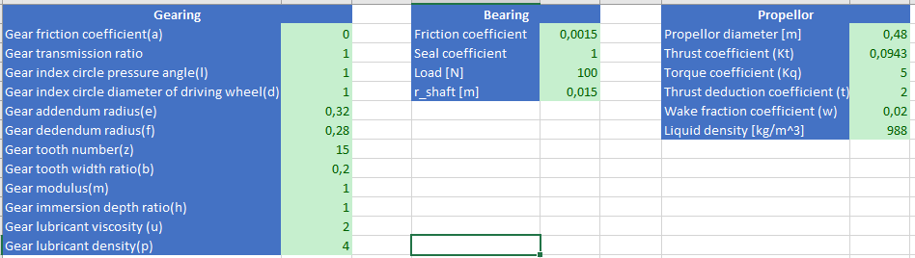

Figure 63 Buildup properties

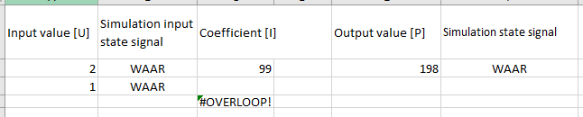

Figure 64 Buildup warnings and prompts

#### Log test data

**Performed steps**

1. Open the user-interface simulation.
2. Set all properties setting value with numeric numbers (without 0)
3. Input a numeric boat speed and record the message box.
4. Input a non-numeric value to boat speed and record the message box.
5. Change some of properties setting values into zero or non-numeric value and record the message box.
6. With the setting in step 5, input any value of boat speeds. Record the message box.

**Results**

This are the results with the simulation:

Properties setting value with numeric numbers:

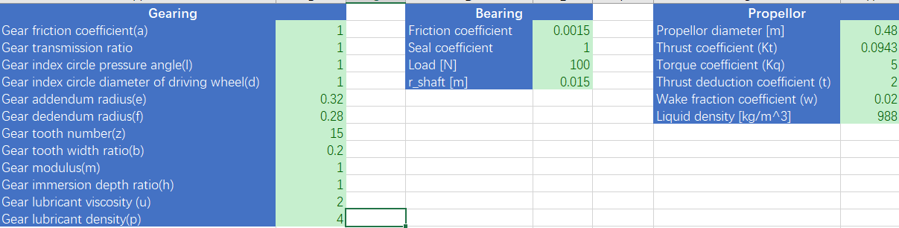

Figure 65 Results properties

Input a numeric boat speed:

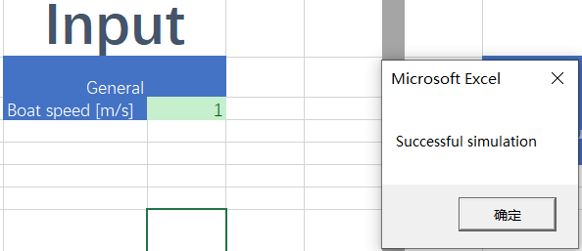

Figure 66 Results numeric boat speed

Input a non-numeric value to boat speed:

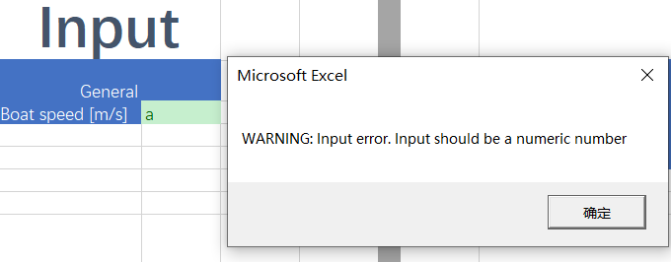

Figure 67 Result non-numeric boat speed

Change some of properties setting values into zero or non-numeric values:

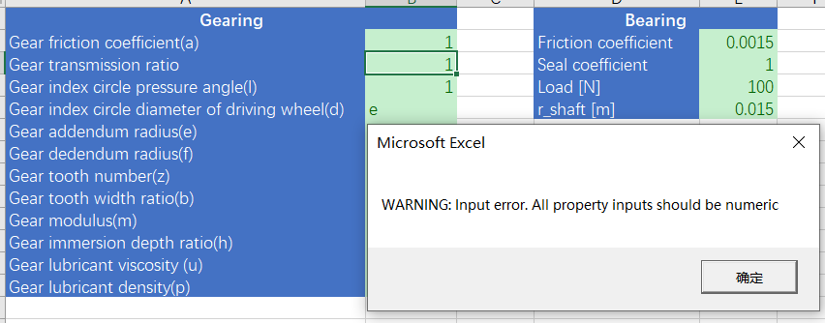

Figure 68 Result properties non-numeric

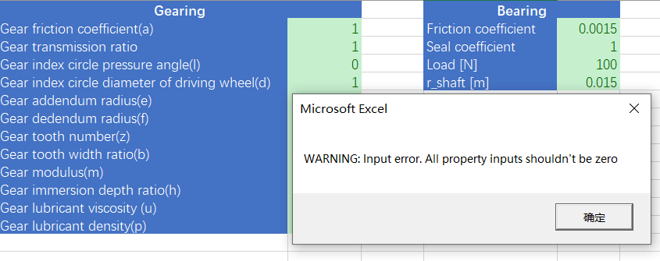

Figure 69 Results properties 0

With the setting in step 5, input any value of boat speeds.

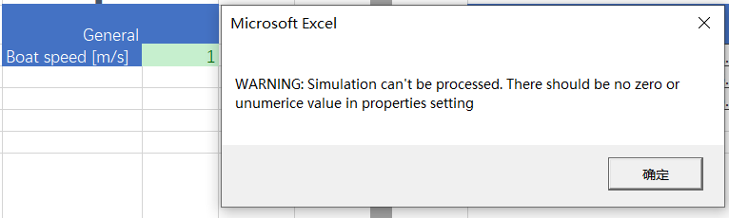

Figure 70 Result prompts

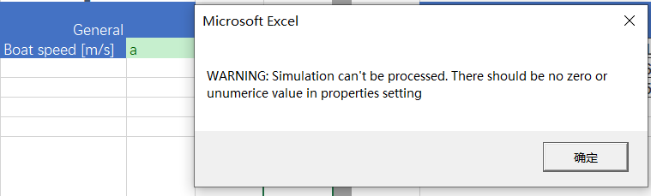

Figure 71 Result 2 prompts

**Conclusion**

The result of this test is same to the desired result list, with different types of inputs, there will be different correct corresponding prompts or warning shown to users. This can remind users the result of simulations and the sources of problems.

|  |  |  |  |
| --- | --- | --- | --- |
| Properties | Boat speed | Message box outputs (In input-output sheet) | Message box outputs (In properties setting sheet) |
| With zero values | No matter what types of value it is. | WARNING: Input error. All property inputs shouldn't be zero | WARNING: Simulation can't be processed. There should be no zero or non-numeric value in properties setting |
| With non-numeric values | WARNING: Input error. All property inputs should be numeric |
| With numeric values | With non-numeric values | - | WARNING: Input error. Input should be a numeric number |
| With numeric values | Successful simulation |

Table 84 Conclusion test user interface

### Subsystem integration (calculations)

#### Build up

This is directly integrated in the user interface.

#### Log test data

**Performed steps**

1. Open the calculation simulation.
2. Set all properties setting values.
3. Input 6 numeric boat speeds and record the output.
4. Compare the simulation results with real data.

**Results**

This are the results with the simulation:

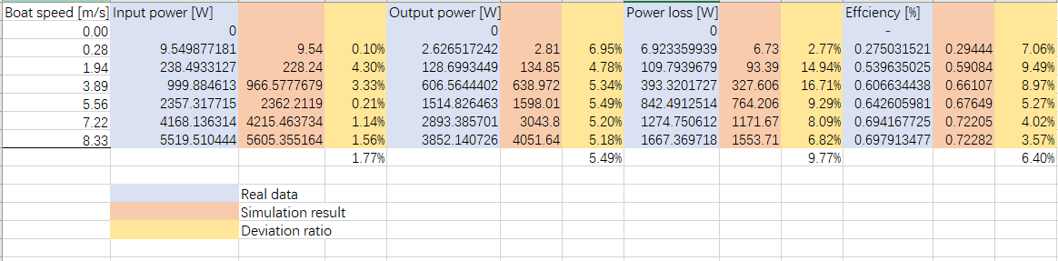

Figure 72 Results sub system calculations

This picture shows the simulation results. Blue blocks contain real data, red block simulation results and yellow blocks contain deviation ratio. The deviation ratios of four outputs are all lower than 10%.

**Conclusion**The results of this test are same to the desired result, with different inputs, there will be different correct corresponding input power, output power, power loss and efficiency. And all results have deviations less than 10%.

## V-model integration phase (system)

### System integration

#### Buildup



Figure 73 Buildup system

#### Log test data

**Performed steps**

1. Set up computer and load in simulation.
2. Insert different boat speeds.
3. Run the simulation for every boat speed.
4. Compare results with the corresponding outputs on the excel datasheet.

**Results**This are the results with from the simulation: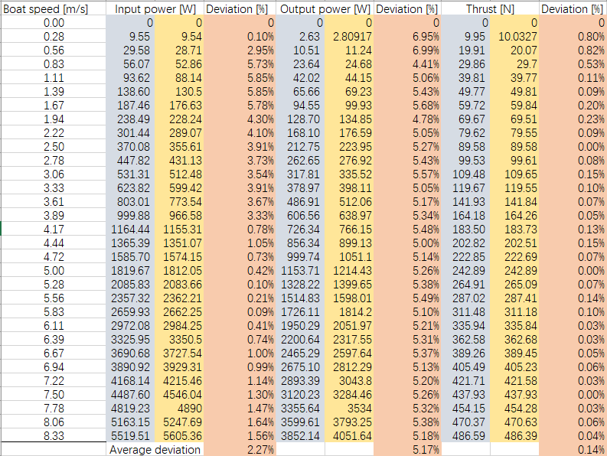

Figure 74 Results system test



Figure 75 Legend system test

This picture shows the simulation results. Blue blocks contain real data, red block simulation results and yellow blocks contain deviation ratio. The deviation ratios of three outputs are all lower than 10%. And most deviations are lower than 5% which shows the system is reliable.

During the usage of simulation. After we input correct values and there are prompts to show successful simulation. When the wrong types of values are entered, there are warnings to remind users to input values in range and with right types of values.

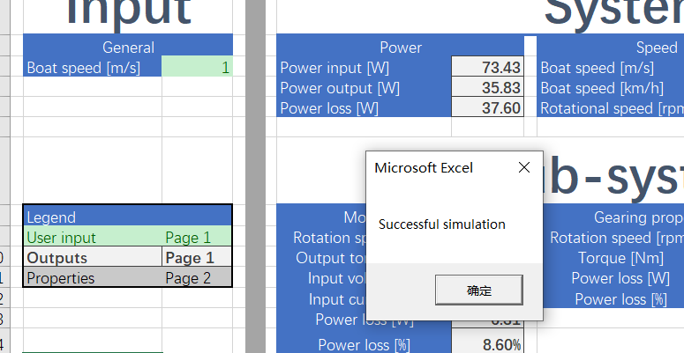

Figure 76 System test successful simulation

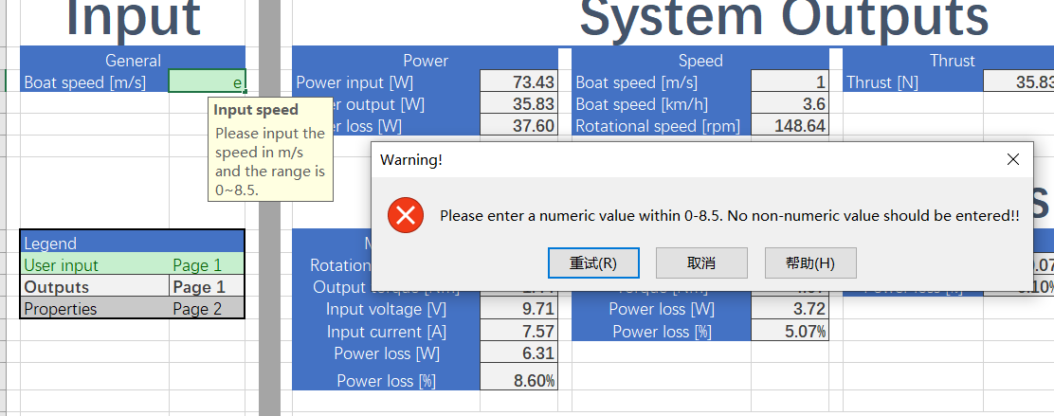

Figure 77 System test unsuccessful simulation

**Conclusion**The results of this test meet the expectation of the desired results, with different inputs, there will be different correct corresponding input power, output power, and thrust. And all results have deviations less than 10%. Meanwhile, with correct inputs, there are prompts for successful simulation. And with wrong inputs, there are different warnings.